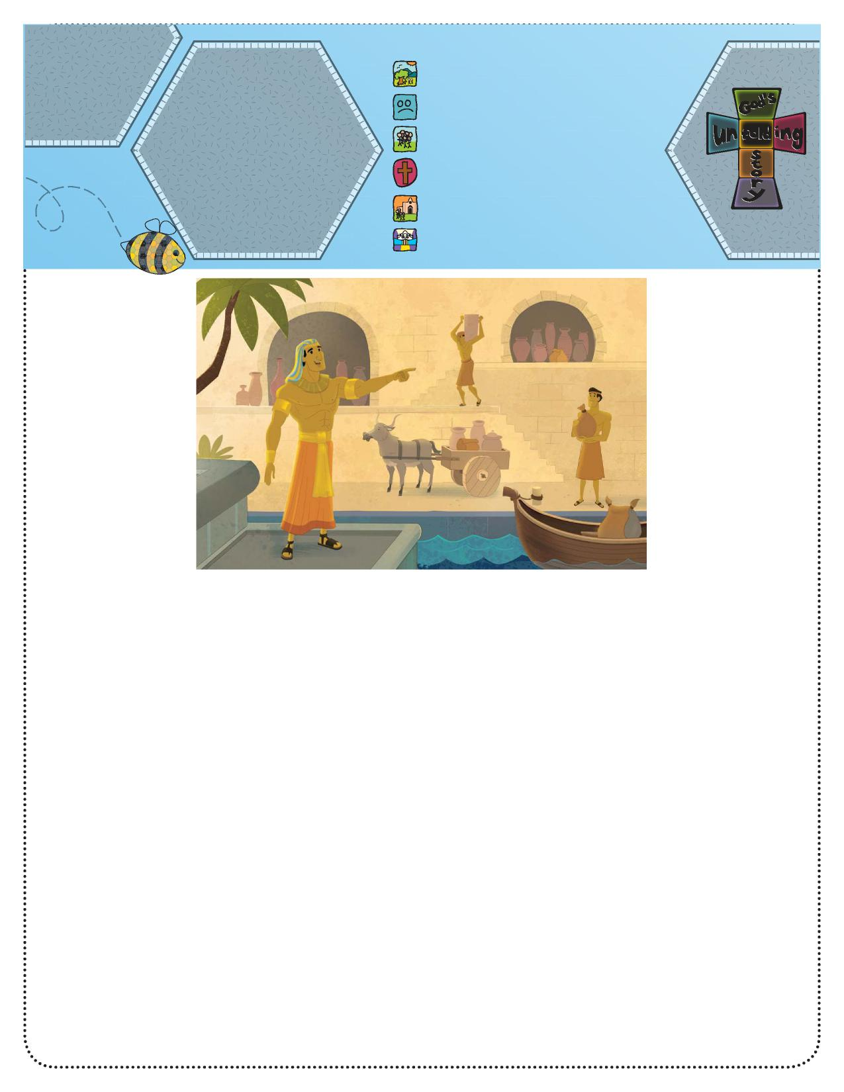

**Parents**

**God’s Unfolding Story**

**Connect Bible Story:** 1. God created everything.

Joseph Helped the

King (Genesis 41)   
**Bible Phrase:**“God will help me”   
(Isaiah 50:7).   
**Bible Truth:**God will help me do   
His work.

1. People disobeyed God.
2. **God chose a special people.**
3. God sent Jesus to help us.
4. Jesus began the Church.
5. Jesus is preparing heaven for us.

**Unfolding God’s Story for Parents**

We are studying about God’s presence with Joseph throughout his life. Parents and children both need to be reminded of God’s love and presence in all of life’s challenges.

Ask, “What do you

think it would be like

to help a president?”

Say, “Joseph helped

the leader of Egypt,

only he was not called a president, but a pharaoh or king.

He was the ruler of all the land.”

Explain, “God can use us to help others, even kings and

presidents.”

Tell the story.

**Bible Story**

**Joseph Helped the King (Genesis 41)** Joseph spent more than two years in the Egyptian prison, but he knew that even though he was in prison, God was with him. One night, as the entire nation slept, the king had two dreams. When the king awoke the next morning, he was very disturbed about his dreams. He knew they meant something important, but he did not understand what. So he called all his helpers and asked them to explain the dreams—but no one understood them.

One of the king’s helpers, the cupbearer, went to the king. He told him that once he had been in prison and had had a dream. The cupbearer said a young man named Joseph helped him know the dream’s meaning. The servant told the king, “Everything happened just as Joseph said.”

So the king called for Joseph. Joseph got all dressed up for his meeting with the king. The king said to Joseph, “I have had dreams, and I need to know what they mean.”

Joseph replied, “I cannot tell you what the dreams mean, but God can.” So the king told Joseph about his dreams, and God helped Joseph know what they meant. Joseph told the king his dreams meant that for seven years, the land would have plenty of food, but after that time the crops would not grow and there would be little food.

The king was grateful for Joseph’s help—so

grateful he put Joseph in charge of all the land. Now Joseph was no longer in prison! He had a very important job and would help many people. God helped Joseph know what to do so the people would have food. In cities all over the land, Joseph made buildings to store grain. For seven years the people brought sacks of grain to the buildings. They filled up all the buildings with grain. After seven years, just as God said, the grain stopped growing. But the people did not go hungry. Joseph had stored enough grain for everyone to have food to eat.

Ask, “What did Joseph do to help the king?” (Explain the dream.)

Ask, “How can you help other people?” (various answers) Say, “God was with Joseph and helped him help the king.” Pray: Thank You, God, for helping us help others.

**Activity Suggestion**

Make a “Helper Chart.” Use a large sheet of paper, colored markers, and a ruler to make a grid with the days of the week across the top and a place to list “ways to help” down the side. Work together to come up with a list of things to do to help others. Use stickers or let your child draw pictures of ways to help.