VBS
Day 1
Sign of the Cross
In the name of the Father, and of the Son, and of the Holy Spirit. Amen
Leader:
Today, we will learn about the Old Testament Joseph, who knew that God was always was with him. In the difficult times Joseph had such as dealing with his jealous brothers, being thrown in a pit, or his brothers selling him into slavery; Joseph always knew God would never abandon him.
We are thankful to Joseph because he teaches us that God is always with us. Joseph was given a coat of many colors; today, this coat will remind us that God is always with us.
No matter where you are- in your home or Tim-Buck-too; God is with you.
No matter who you are with- your mom or Pope Francis, God is with you.
Today, let us open our hearts to knowing God is with us always.
We ask this through Christ our Lord,
Amen
Day 2
Sign of the Cross
In the name of the Father, and of the Son, and of the Holy Spirit. Amen
Leader:
Today, we learn that Joseph believed God cared for him. Joseph was put in difficult situations. Joseph was enslaved, falsely accused, and put in prison as an innocent person. No matter what, Joseph knew God cared for him.
We are thankful to Joseph because he teaches us that God cares us. Joseph was given the ability to interpret dreams; today, a pillow will remind us that God cares us.
No matter where you are- in your school or Tim-Buck-too; God cares for you.
No matter who you are with- your dad or Pope Francis, God cares for you.
Today, let us open our hearts to knowing God cares for us always.
We ask this through Christ our Lord,
Amen

Day 3
Sign of the Cross
In the name of the Father, and of the Son, and of the Holy Spirit. Amen
Leader:
Today, we learn that Joseph believes God forgives. Joseph was put in difficult situations by his brothers. When his brothers came to Egypt looking for food, he did not kill them for throwing him in a pit and enslaving him. No. Joseph knew that God forgives, so he too should forgive his brothers.
We are thankful to Joseph because he teaches us that God forgives us. Joseph forgave his brothers who had done bad things to him, today we will use a cup to remind us that God forgives us.
No matter where you are- in your church or Tim-Buck-too; God forgives you.
No matter who you are with- your teacher or Pope Francis, God forgives you.
Today, let us open our hearts to knowing God forgives us always.
We ask this through Christ our Lord,
Amen
Day 4
Sign of the Cross
In the name of the Father, and of the Son, and of the Holy Spirit. Amen
Leader:
Today, we learn that Joseph knew that God is good. After many years of Joseph being kept from his family, he was reunited with them. Joseph knew that even though he had difficulties and hardship, God’s plan was for good.
We are thankful to Joseph because he teaches us that God is good to us. Joseph was reunited with his family; today, a family photo will remind us that God is good to us.
No matter where you are- in a car or Tim-Buck-too; God is good to you.
No matter who you are with- your brother or Pope Francis, God is good to you.
Today, let us open our hearts to knowing God is good to you always.
We ask this through Christ our Lord,
Amen

Day 1 Pictures
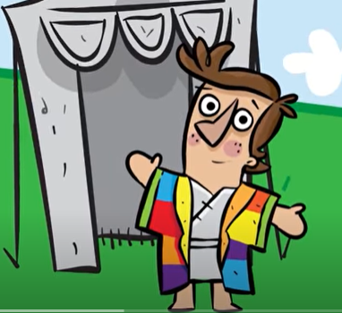
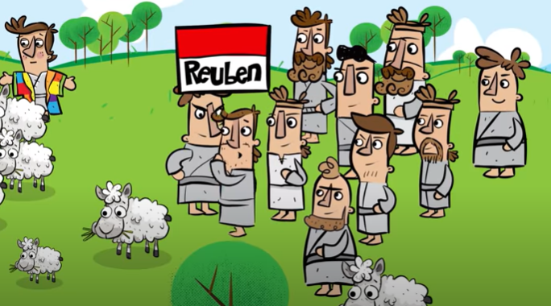

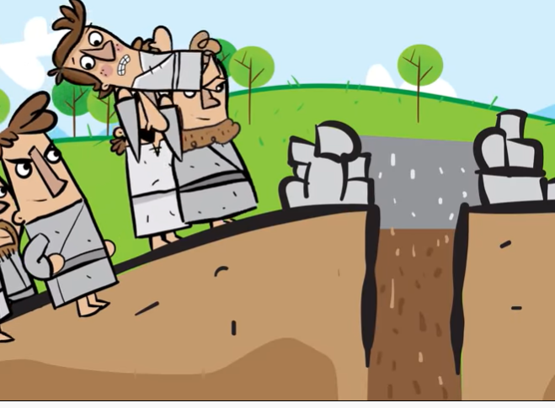
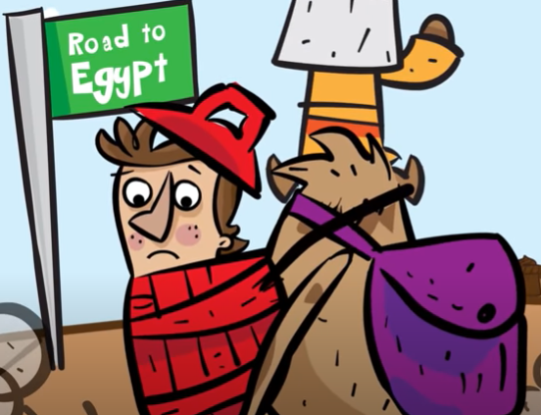
Day 2
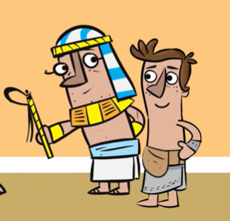
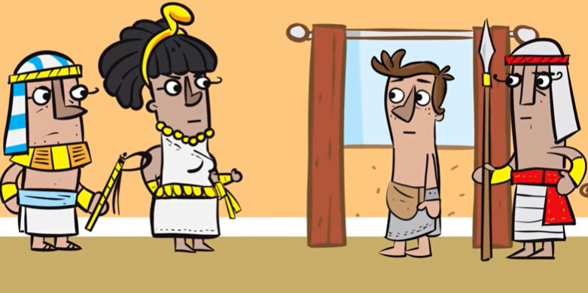
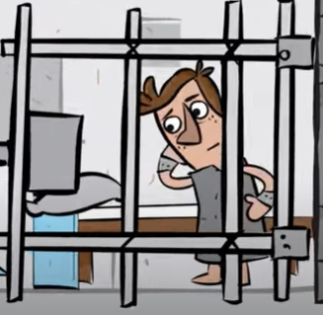
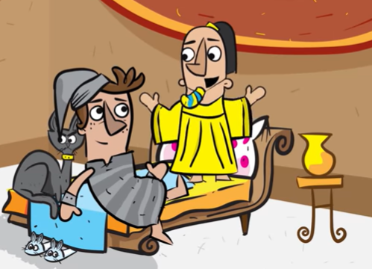
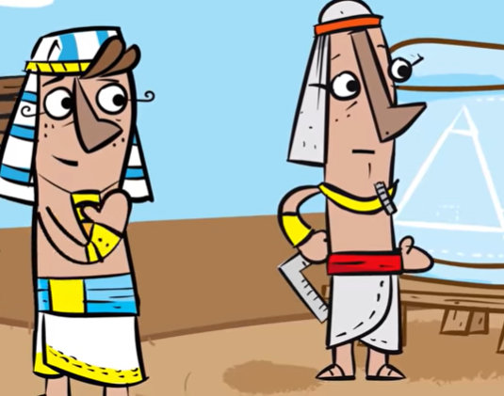
Day 3
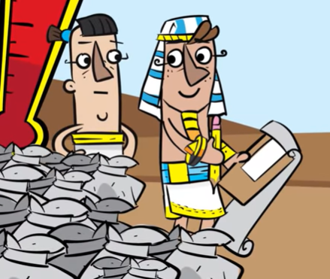
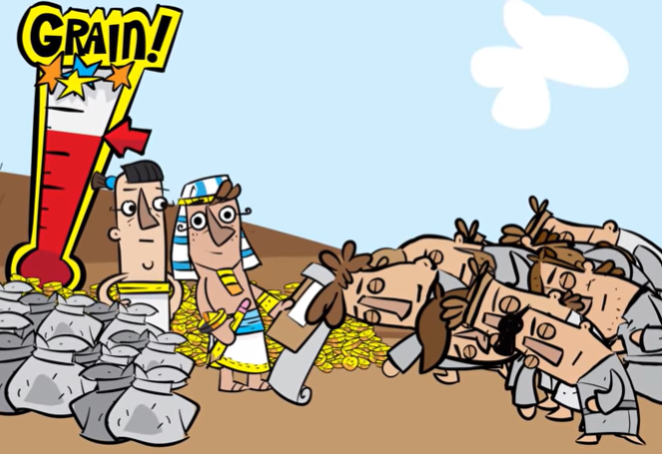
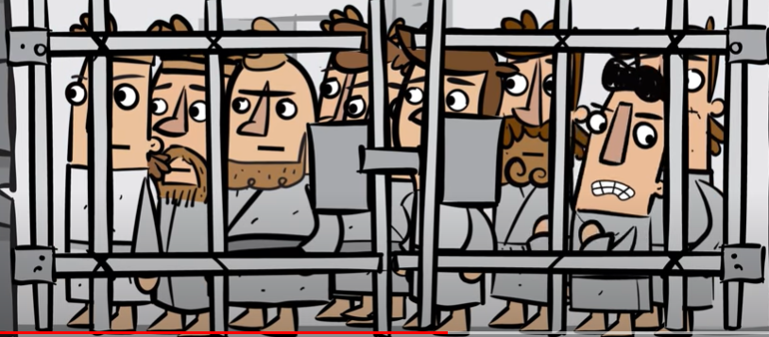
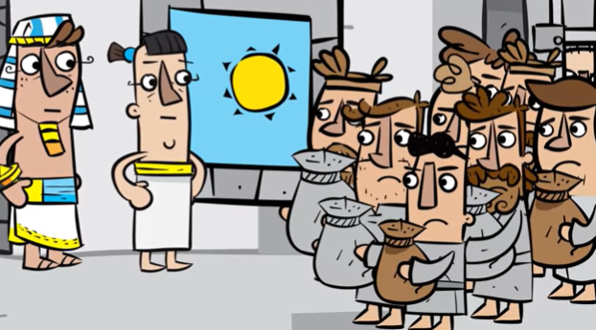
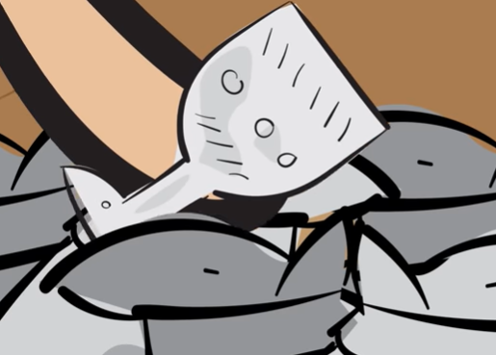
DAY 4
