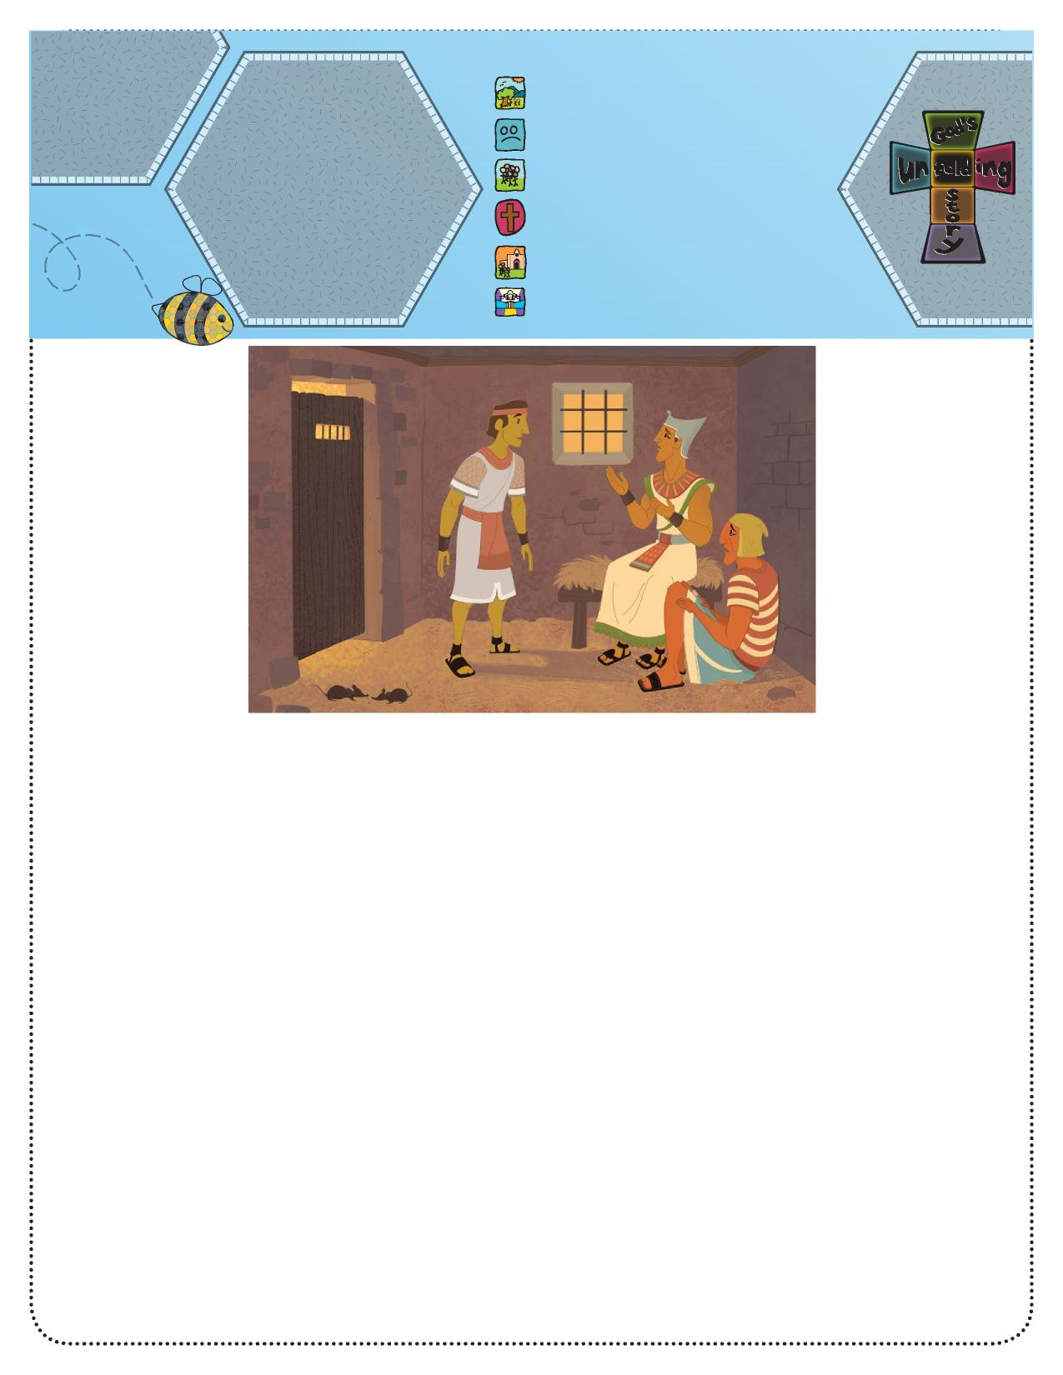

**Parents**

**Bible Story:**

**God’s Unfolding Story**

**Connect** God Was with 1. God created everything.

Joseph in Egypt   
(Genesis 39–40)   
**Bible Phrase:** “God was   
with Joseph” (Genesis 39:2).   
**Bible Truth:** God will always   
be with me and help me   
do what is right.

1. People disobeyed God.
2. **God chose a special people.**
3. God sent Jesus to help us.
4. Jesus began the Church.
5. Jesus is preparing heaven for us.

**Unfolding   
God’s Story   
for Parents**

We are studying about

God’s presence with

Joseph through all the

challenges he faced.

As adults, we can

understand the details

of the challenges

Joseph faced. We

will not share all

the details with our

children, but they

can understand the

Bible truth. Look for

opportunities to affirm

that just as God was with Joseph, He is with us today.

Say, “Last week we learned that Joseph went a long way from home, but God was still with him. Today we will see that even in prison, God took care of Joseph.”

Tell the story.

**Bible Story**

**God Was with Joseph in Egypt**

**(Genesis 39–40)**

Joseph was a young man who was living in a country called Egypt. Egypt was not Joseph’s home. Joseph’s brothers had made some bad choices that caused Joseph to be taken far away from his home. But God was with Joseph, and God allowed many good things to happen to Joseph and to the people for whom Joseph worked. We will learn that Joseph served God even though he often was treated unfairly.

Joseph worked for a man named Potiphar. Every day Joseph did his best as he worked in Potiphar’s house. One day Potiphar said to Joseph, “You are a very hard worker. I have decided to put you in charge of all the helpers in my house.” Joseph knew this would be hard work, but God helped him with his work.

One day Joseph was blamed for doing something he did not do. Potiphar got very angry and put Joseph in prison! But God was

with Joseph. God helped Joseph work hard and do his best for the prison master. The master liked Joseph and appreciated his hard work. One day the master said to Joseph, “Today I am putting you in charge of all the prisoners.” Again Joseph knew that God would help him to a good job.

One morning Joseph noticed one of his prisoners was sad. The prisoner had been a servant of the king, but one day the king got

angry with him and put him in prison. The man had a dream during the night and wondered about what it meant. Joseph asked him to tell him his dream. God helped Joseph understand that the dream meant the man soon would be out of prison. Joseph explained the dream and asked the man to remember him with kindness when he was no longer in jail. The man was freed, just as Joseph said, but he forgot about Joseph. Even though Joseph stayed in prison, he knew God was with him, and he continued to serve Him faithfully.

Ask, “What bad things happened to Joseph?” (He was put in

prison for something he did not do.)

Ask, “How do we know God was with Joseph? (God helped

Joseph tell the other man what his dream meant.)

Say, “God took care of Joseph even while he was in prison.”

**Activity Suggestion**

Make a “God Is With Me All the Time Mirror Reminder.” Cut out a 4” or 5” circle in the middle of a piece of paper (any color). Write the Bible Truth at the top of the page. Let your child draw pictures of home, church, car, preschool, and other places that he may go. After he colors the pictures, tape the sheet to his mirror so that he can see his face in the circle and be reminded that God is with him all the time.