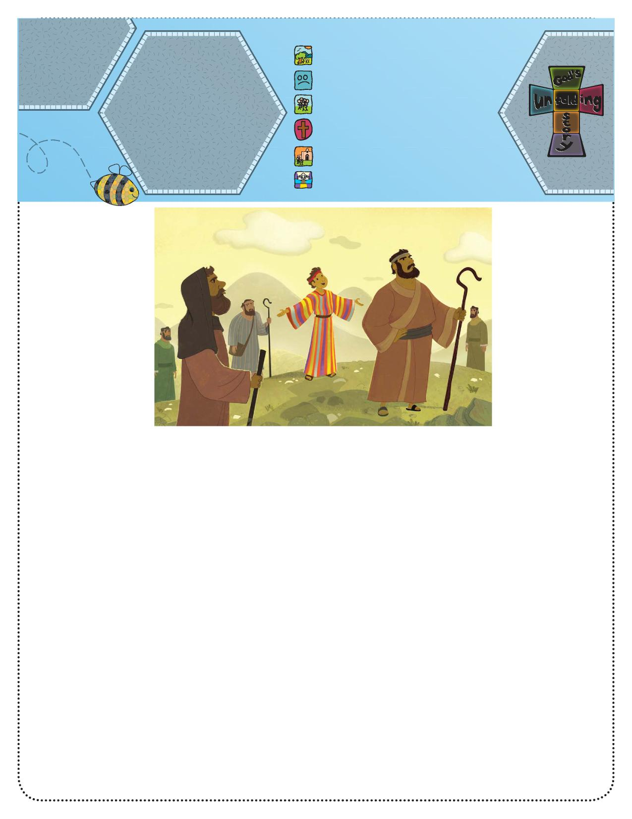

**God’s Unfolding Story**

**Parents Connect**

**Bible Story:**Joseph’s Special   
Coat (Genesis 37)   
**Bible Phrase:**“The Lord your God is   
with you wherever you go”   
(Joshua 1:9).   
**Bible Truth:** God will   
always be with me   
wherever I go.

1. God created everything.
2. People disobeyed God.
3. **God chose a special people.**
4. God sent Jesus to help us.
5. Jesus began the Church.
6. Jesus is preparing heaven for us.

**Unfolding**

**God’s Story For Parents**

During this four-week unit we will see that God was with Joseph through all the challenges that he faced. As you teach your children, look for opportunities to affirm that just as God was with Joseph, He is with us today.

Say, “Today’s story is

about a young man who went a long way from home, but

God was always with him.”

Tell the story.

**Bible Story**

**Joseph’s Special Coat (Genesis 37)**

A very long time ago there lived a man named Jacob. Jacob had 12 sons. One of the younger sons was named Joseph. Jacob loved Joseph a lot and made a beautiful, colorful coat for him. Joseph felt very special to have the coat, but his older brothers did not think Joseph was so special. Maybe they were disappointed they did not have colorful coats themselves.

Joseph would help his brothers take care of his father’s sheep. One day, perhaps as Joseph’s brothers were watching the sheep, Joseph told his brothers about a strange dream he had had. It pictured Joseph’s family bowing to Joseph as if he were their king. Then Joseph dreamed another dream that showed the same thing, and he told his brothers about that one, too. The big brothers thought the dreams were silly, and they laughed at Joseph—but they also grew angry.

Not long after this, Joseph’s father sent him out to find his brothers who were taking care of the sheep. As Joseph came near his brothers, they saw him in the distance. They knew it was Joseph because of his colorful coat. They were not happy to see him, and they didn’t want to hear any more about his

dreams. When Joseph reached his brothers, they made some wrong choices and sent Joseph to live far away from his family. But Joseph learned God was with him wherever he went. Later, Joseph learned God had a very important plan for his life.

Ask, “What did Joseph’s father give him?” (a colorful coat)

Ask, “Who did Joseph go to find?” (his brothers)

Say, “God took care of Joseph in all of his travels.”

Pray, thanking God for His presence.

**Activity Suggestion**

Help your child make a “colorful coat.” Use a coffee filter, washable markers, and a spray bottle of water. Sketch a basic outline of a coat using either a pencil or a permanent felt tip marker. Guide your child to use several bright colors of washable markers to make the colors on the coat. Lightly spray with water to get the colors to run together. Let the “coat” dry, then cut it out and put it on a doll or stick puppet.