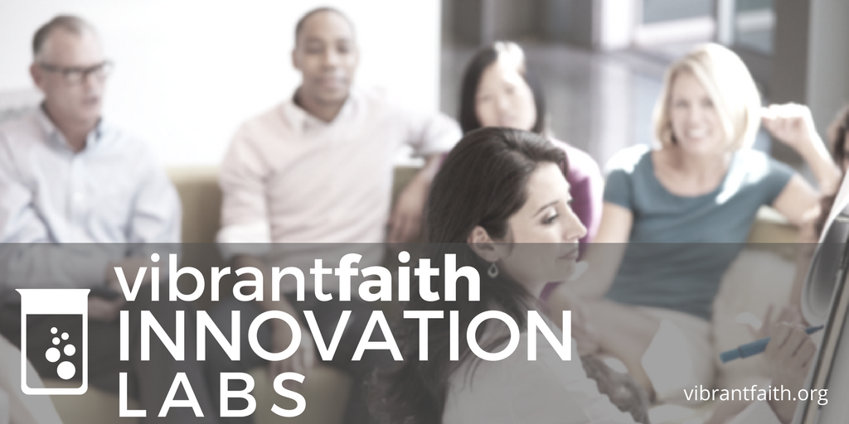
Digital Faith Formation Innovation Lab
Presenter: John Roberto, Vibrant Faith Leadership Team
Email: jroberto@lifelongfaith.com
VibrantFaith.org LifelongFaith.com SeasonsofAdultFaith.com

Program
- The Digital Transformation of Faith Formation
- Blended Models of Faith Formation
- Online Models of Faith Formation
- Designing Digital Platforms for Faith Formation
- Curating Faith Formation

Resources
Handouts/Resources/PowerPoint Presentations: https://www.lifelongfaith.com/digital-faith-formation.html
Roberto, John. Reimagining Faith Formation for the 21st Century. Naugatuck: LifelongFaith Associates, 2015. (available at www.LifelongFaith.com)
Roberto, John, editor. The Seasons of Adult Faith Formation. Naugatuck: LifelongFaith Associates, 2015. (available at www.LifelongFaith.com)
Roberto, John, editor. Families at the Center of Faith Formation. Naugatuck: LifelongFaith Associates, 2016. (available at www.LifelongFaith.com)

Families at the Center of Faith Formation website: http://www.FamiliesattheCenter.com
Seasons of Adult Faith Formation website: www.SeasonsofAdultFaith.com.
Strategies

- Extend a church event or program
- Design one event or program, offer it in multiple platforms
- Prepare for and follow-up an event or experience
- Flip a gathered program
- Integrate online and gathered
- Create online only experiences
- Use webinars, Facebook live, podcasts, etc. to deliver programming directly to people

Blended Faith Formation Continuum

Online Face-to-Face
Fully Online  An online program with all learning done online and limited face-to-face, gathered learning settings | Mostly Online  A mostly online program with opportunities for regular interaction in face-to-face, gathered settings | Online and Gathered  Online learning focused on presenting the content of the program combined with face-to-face, gathered sessions using active learning methods to discuss, practice and apply the content. | Gathered and  Online Content  A gathered event or program that provides online content and activities to extend and expand the learning from the gathered program | Gathered with Online Content  A gathered event or program that uses online content as part of the design of the event or program

- Gathered Program with Online Content: We can design a gathered program using online content from websites, videos from YouTube or other video sites, and blogs and other social media. With an abundance of high quality digital content, this first option is the easiest way to bring the digital world into a gathered program.

- Gathered Program and Online Content: We can connect church programs or events with online content that extends and deepens the experience through learning, prayer, ritual, action, etc. Gathered events and programs such as Sunday worship, church year feasts and seasons intergenerational and family programs, classes, youth group meetings, mission trips, retreat experiences, and vacation Bible school would all benefit from extending the experience with digital content for learning, praying, celebrating, having faith conversations, acting/serving, and more.

Example: Provide a complete faith formation experience online connected to the life of the church, e.g., forty-day Lent “curriculum” that connects the Lent events at church with online content for experiencing and practicing Lent in daily and home life.

- Online and Gathered: We can “flip the classroom or program” by creating a digital platform to provide the content that people would learn in the gathered setting in an online learning space using print, audio, video, and more. And then transform the gathered program using interactive activities, discussion, project-based learning, and practice and demonstration.

Example: “Flip the classroom or program” by creating a digital platform to provide the content that people would learn in the gathered setting in an online learning space using print, audio, video, and more. And then transform the gathered program using interactive activities, discussion, project-based learning, and practice and demonstration. One example is redesigning children’s faith formation so that children and their parents are learning online at home and doing activities together, and then refocusing “class time” to engage children in creating projects and activities that demonstrate their learning. Another example is designing a high school confirmation program that provides the content that used to be taught in the weekly sessions in an online platform for individual learning—watching videos, reading short materials, and writing a reflection journals; engages the young people in small groups during the month to discuss their online learning; and then meets monthly in a large group gathered session for discussion, interactive activities, and application of the content to living as a Christian today. During the year retreats, worship, and service projects offer additional gathered sessions.

- Mostly Online: We can offer opportunities for individuals, families, and small groups to utilize the digital platform as their primary learning setting and provide opportunities for regular interaction in face-to-face, gathered settings or in a web conference format.

Example: Offer six, one-hour parent webinar programs delivered to parents at home in four-month semesters: three webinars followed by a parent gathering at church; three more webinars and concluding with a parent gathering at church. Another example is developing an online Bible study where groups can meet regularly in a physical setting or virtually through Skype or a Google+ Hangout for sharing their learning.

- Fully Online: The rise of high quality and easily accessible online religious content—courses, activities, print and e-books, audio and video programs, and content-rich websites—has made designing online faith formation feasible.

Example: Offer adults a variety of online Bible and theology courses for individual study using online courses from colleges, and seminaries, video programs on YouTube, online programs and webinars from religious publishers and organizations. Another example is providing an online prayer and spirituality center where people can access daily prayer reflections and devotions, offer prayer intentions, pray for others, learn about spiritual practices, download prayer activities for the home, and more.

