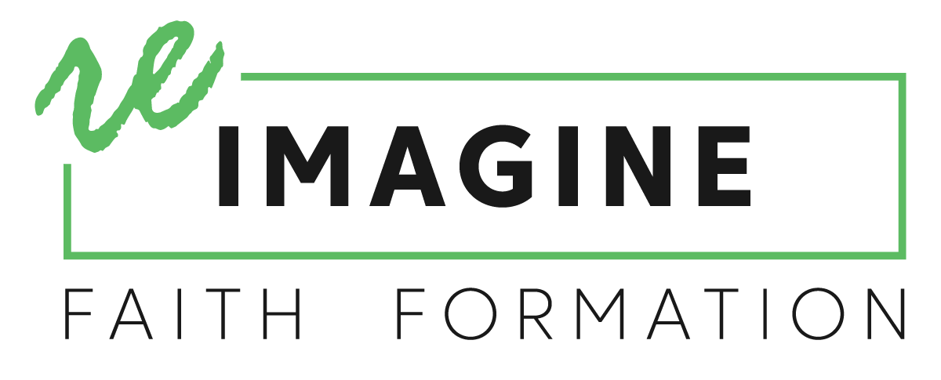
Developing a Plan for Supporting Leaders in
Developing Innovative Family Faith Formation Initiatives

A Plan for Training and Coaching/Consulting with Parishes
- Training: Conducting the two-day Families at the Center of Faith Formation Workshop
- Coaching/Consulting: Engaging diocesan staff in a coaching/consulting relationship with a group of parishes, organized geographically or based on the projects or the type of parish (urban, suburban, small town, mono-ethnic, multi-ethnic).
- Online Support and Networking: Using a digital platform like Slack (https://slack.com) for communicating among leaders sharing projects, and accessing resources and tools. Developing a website specifically for this project.
- Webinar #1: Conducting an online Design Clinic to guide parishes in designing strategies and their digital platform.
- Webinar #2: Conducting an online Launch webinar to prepare leadership teams for implementing their innovation.
- Gathering: Conducting an Gathering of parishes to share projects, address issues, plan for continuing growth, etc.
- Webinar #3: Conducting a Project Evaluation webinar to introduce the tools and processes for evaluating the impact of the projects (at the end of the first year).
- Closing Gathering: Conducting a Gathering to share the first year results of projects and plan for the second year.

A Plan for Resourcing Parishes: Creating Learning Environments
A learning environment is a deliberately curated collection of materials and activities to support the development of a specific knowledge base or skill set.

