We Pray for Those Who Have Died

____________________________________________________________________________________

____________________________________________________________________________________

____________________________________________________________________________________

____________________________________________________________________________________

____________________________________________________________________________________

____________________________________________________________________________________

____________________________________________________________________________________

____________________________________________________________________________________

____________________________________________________________________________________

____________________________________________________________________________________

____________________________________________________________________________________

____________________________________________________________________________________

____________________________________________________________________________________

____________________________________________________________________________________

____________________________________________________________________________________

____________________________________________________________________________________

____________________________________________________________________________________

____________________________________________________________________________________

____________________________________________________________________________________

I am the resurrection and the life; whoever believes in me, even if he dies, will live, and everyone who lives and believes in me, will never die. (John 11:25-26)

My Headstone

Scripture Readings for the
Funeral Liturgy

Old Testament Reading: Isaiah 25:6a, 7-9
On this mountain the Lord of hosts will provide for all peoples A feast of rich food and choice wines, juicy, rich food and pure, choice wines. On this mountain he will destroy the veil that veils all peoples, the web that is woven over all nations; he will destroy death forever. The Lord God will wipe away the tears from all faces; the reproach of his people he will remove from the whole earth; for the Lord has spoken. On that day it will be said: “Behold our God, to whom we looked to save us! This is the Lord for whom we looked; let us rejoice and be glad that he has saved us!”

Responsorial Psalm: Psalm 23
The Lord is my shepherd; there is nothing I lack.
In green pastures you let me graze; to safe waters you lead me; you restore my strength.
You guide me along the right path for the sake of your name.
Even when I walk through a dark valley, I fear no harm for you are at my side; your rod and staff give me courage.
You set a table before me as my enemies watch; You anoint my head with oil; my cup overflows.
Only goodness and love will pursue me all the days of my life; I will dwell in the house of the Lord for years to come.

New Testament Reading: 2 Timothy 2:8-13
Remember Jesus Christ, raised from the dead, a descendant of David: such is my gospel, for which I am suffering, even to the point of chains, like a criminal. But the word of God is not chained. Therefore, I bear with everything for the sake of those who are chosen, so that they too may obtain the salvation that is in Christ Jesus, together with eternal glory. This saying is trustworthy: If we have died with him we shall also live with him; if we persevere we shall also reign with him. But if we deny him he will deny us. If we are unfaithful he remains faithful, for he cannot deny himself.

Gospel Reading: John 11:1-44 (Raising of Lazarus)
Now a man was ill, Lazarus from Bethany, the village of Mary and her sister Martha. Mary was the one who had anointed the Lord with perfumed oil and dried his feet with her hair; it was her brother Lazarus who was ill. So the sisters sent word to him, saying, “Master, the one you love is ill.” When Jesus heard this he said, “This illness is not to end in death, but is for the glory of God, that the Son of God may be glorified through it.” Now Jesus loved Martha and her sister and Lazarus. So when he heard that he was ill, he remained for two days in the place where he was.
Then after this he said to his disciples, “Let us go back to Judea.” The disciples said to him, “Rabbi, the Jews were just trying to stone you, and you want to go back there?” Jesus answered, “Are there not twelve hours in a day? If one walks during the day, he does not stumble, because he sees the light of this world. But if one walks at night, he stumbles, because the light is not in him.” He said this, and then told them, “Our friend Lazarus is asleep, but I am going to awaken him.” So the disciples said to him, “Master, if he is asleep, he will be saved.” But Jesus was talking about his death, while they thought that he meant ordinary sleep. So then Jesus said to them clearly, “Lazarus has died. And I am glad for you that I was not there, that you may believe. Let us go to him.” So Thomas, called Didymus, said to his fellow disciples, “Let us also go to die with him.”

When Jesus arrived, he found that Lazarus had already been in the tomb for four days. Now Bethany was near Jerusalem, only about two miles away. And many of the Jews had come to Martha and Mary to comfort them about their brother. When Martha heard that Jesus was coming, she went to meet him; but Mary sat at home. Martha said to Jesus, “Lord, if you had been here, my brother would not have died. (But) even now I know that whatever you ask of God, God will give you.” Jesus said to her, “Your brother will rise.” Martha said to him, “I know he will rise, in the resurrection on the last day.” Jesus told her, “I am the resurrection and the life; whoever believes in me, even if he dies, will live, and everyone who lives and believes in me will never die. Do you believe this?” She said to him, “Yes, Lord. I have come to believe that you are the Messiah, the Son of God, the one who is coming into the world.”

When she had said this, she went and called her sister Mary secretly, saying, “The teacher is here and is asking for you.” As soon as she heard this, she rose quickly and went to him. For Jesus had not yet come into the village, but was still where Martha had met him. So when the Jews who were with her in the house comforting her saw Mary get up quickly and go out, they followed her, presuming that she was going to the tomb to weep there. When Mary came to where Jesus was and saw him, she fell at his feet and said to him, “Lord, if you had been here, my brother would not have died.” When Jesus saw her weeping and the Jews who had come with her weeping, he became perturbed and deeply troubled, and said, “Where have you laid him?” They said to him, “Sir, come and see.” And Jesus wept. So the Jews said, “See how he loved him.” But some of them said, “Could not the one who opened the eyes of the blind man have done something so that this man would not have died?”

So Jesus, perturbed again, came to the tomb. It was a cave, and a stone lay across it. Jesus said, “Take away the stone.” Martha, the dead man's sister, said to him, “Lord, by now there will be a stench; he has been dead for four days.” Jesus said to her, “Did I not tell you that if you believe you will see the glory of God?” So they took away the stone. And Jesus raised his eyes and said, “Father, I thank you for hearing me. I know that you always hear me; but because of the crowd here I have said this, that they may believe that you sent me.” And when he had said this, he cried out in a loud voice, “Lazarus, come out!” The dead man came out, tied hand and foot with burial bands, and his face was wrapped in a cloth. So Jesus said to them, “Untie him and let him go.”

Celebrating the Funeral Liturgy:
Rite, Prayers, and Symbols
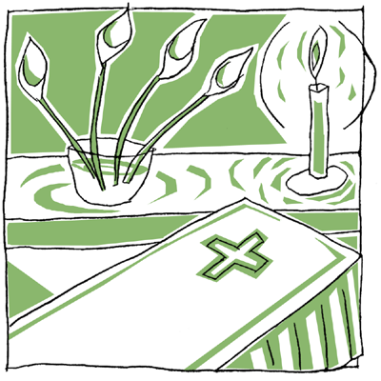

1. Introductory Rites

- Greeting
May the Father of mercies, the God of all consolation be with you.
- Sprinkling with Holy Water
In the waters of baptism N. died with Christ and rose with him to new life. May he/she now share with him eternal glory.
- Placing of the Pall
- Entrance Procession and Easter Candle
- Placing of the Christian Symbols
- Book of the Gospels or Bible
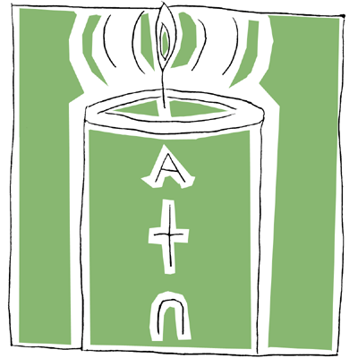
In life N. cherished the Gospel of Christ. May Christ now greet him/her with these words of eternal life: Come, blessed of my Father!
- Cross
In baptism N. received the sign of the cross. May he/she now share in Christ’s victory over sin and death.
- Opening Prayer (#164 A and B)
Almighty God and Father, it is our certain faith that your Son, who died on the cross, was raised from the dead, the firstfruits of all who have fallen asleep. Grant that through this mystery your servant N., who has gone to his/her rest in Christ, may share in the joy of his resurrection.
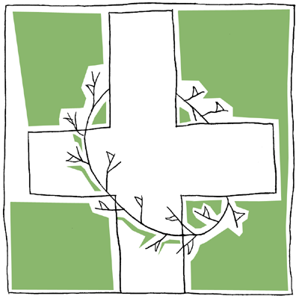

O God, to whom mercy and forgiveness belong, hear our prayers on behalf of your servant N., whom you have called out of this world; and because he/she put his/her hope and trust in you, command that he/she be carried safely home to heaven and come to enjoy your eternal reward.

2. Liturgy of the Word

- Readings: Old Testament, Psalm, New Testament, and Gospel
- Homily
- Intercessions
God, almighty Father, raised Christ his Son from the dead; with confidence we ask him to save all his people, living and dead:
For N. who in baptism was given the pledge of eternal life, that he/she may now be admitted to the company of the saints. We pray to the Lord:
R/. Lord, hear our prayer.
For our deceased relatives and friends and for all who have helped us, that they may have the reward of their goodness. We pray to the Lord:
R/. Lord, hear our prayer.
For those who have fallen asleep in the hope of rising again, that they may see God face to face. We pray to the Lord:
R/. Lord, hear our prayer.
For the family and friends of our brother/sister N., that they may be consoled in their grief by the Lord, who wept at the death of his friend Lazarus. We pray to the Lord:
R/. Lord, hear our prayer.
For all of us assembled here to worship in faith, that we may be gathered together again in God’s kingdom. We pray to the Lord:
R/. Lord, hear our prayer.
God, our shelter and our strength,
you listen in love to the cry of your people: hear the prayers we offer for our departed brothers and sisters. Cleanse them of their sins and grant them the fullness of redemption. We ask this through Christ our Lord
R/. Amen

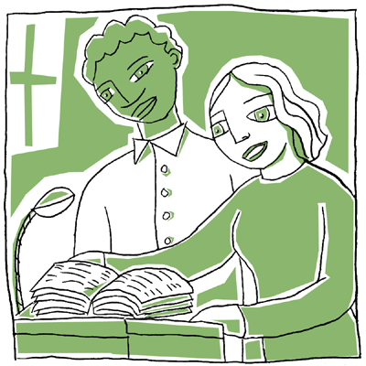
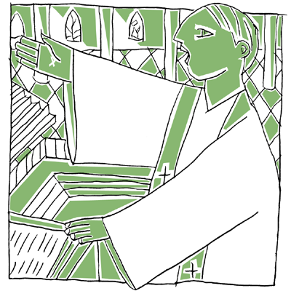
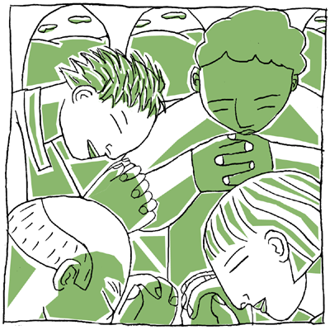
3. Liturgy of the Eucharist

4. Final Commendation

- Invitation to Prayer (#171)
Before we go our separate ways, let us take leave of our brother/sister. May our farewell express our affection for him/her; may it ease our sadness and strengthen our hope. One day we shall joyfully greet him/her again when the love of Christ, which conquers all things, destroys even death itself.
- Silence
- Signs of Farewell
- Song of Farewell
- Prayer of Commendation (#175)
Into your hands, Father of mercies,
we commend our brother/sister N.
in the sure and certain hope
that, together with all who have died in Christ, he/she will rise with him on the last day.

We give you thanks for the blessings
which you bestowed upon N. in this life:
they are signs to us of your goodness
and of our fellowship with the saints in Christ.

Merciful Lord, turn toward us and listen to our prayers: open the gates of paradise to your servant and help us who remain to comfort one another with assurances of faith, until we all meet in Christ and are with you and with our brother/sister for ever.

5. Procession to the Place of Committal

In peace let us take our brother/sister to his/her place of rest.



