Symposium 2017: Faith Formation with a New Generation
Faith Maturing: Childhood through Adolescence

What does a maturing Christian look like at the close of the first two decades of life?
What are appropriate expectations for faith formation in the first two decades of life?
What do we hope to accomplish in the lives of young people from 0-19 years old.

Characteristics of Maturing Christian Youth

Viewed from the perspective of the young person at 19 years old, we can identify at least thirteen characteristics of maturing committed Christian youth. These characteristics are drawn from research of faith maturing in young people and from the wisdom of the Christian leaders engaged in faith formation with children and adolescents. These thirteen characteristics are foundational. They are developmentally-appropriate, realistic expectations for faith maturing in the first two decades of life. They provide the beginnings of lifelong process of growth in Christian faith and discipleship. They provide a perspective to view faith maturing in the first two decades of life and a guide to building developmentally-appropriate faith formation from childhood through adolescence that has direction and purpose.

But these characteristics are not the final word. These characteristics need to be contextualized within specific Christian churches and their traditions, within the specific ethnic-cultural traditions and identifies of faith communities, and within the unique socio-cultural needs of faith communities. These thirteen characteristics are descriptive, not prescriptive. They serve as a guide for congregations to develop faith formation with children and adolescents. They provide a way to direct energy and attention to specific goals or outcomes. And they provide a way to develop a seamless process of fostering faith growth from 0-19 years old.

- Sustaining a personal relationship with Jesus Christ supported through regular prayer, faith sharing and Bible reading.
- Making the Christian faith a way of life by integrating their beliefs into the conversation, decisions, and actions of daily life.
- Possessing a vital faith and being aware of God present and active in their own life, the lives of others, and the life of the world.
- Seeking spiritual growth by actively pursuing questions of faith, learning what it means to believe in God, and what it’s like to be a disciple of Jesus Christ.
- Living a life of service by caring for others, reaching out those in need, and addressing injustice in the world.
- Sharing the Good News through words and actions, through Christian stewardship and working for peace, justice and human dignity.
- Participating fully, consciously, actively and regularly in the ritual and worship life of the faith community.
- Articulating the fundamental teachings of the Christian faith and demonstrating a commitment to learning and growing in this faith.
- Exercising moral responsibility by applying Christian ethics, virtues, principles, values, and social teaching to moral decision-making, life situations, and in interactions with the larger culture.
- Practicing faith in Jesus Christ, privately and publicly, through participation in the congregation’s worship, ministries, and leadership.
- Discerning and using their gifts to actively belong to and participate in the life and mission of the Christian community.
- Exploring God’s call to vocation through prayer, reflection, and discernment.
- Possessing a positive spirit with loving and hopeful attitudes toward others and life, convinced that they can make the world a better place.

Promoting Growth in Faith and Discipleship

There are at least eight essential processes of forming faith—informed by Scripture, theology, research, and contemporary reflection—that promote faith growth and discipleship with all ages, with families, and with the whole faith community.

- Caring relationships. Growing in faith and discipleship through caring relationships across generations and in a life-giving spiritual community of faith, hope, and love—in the congregation and family.
- Celebrating the liturgical seasons: Growing in faith and discipleship by experiencing the feasts and seasons of the church year as they tell the story of faith through the year in an organic and natural sequence of faith learning.
- Celebrating rituals and milestones. Growing in faith and discipleship by celebrating rituals, sacraments, and milestones that provide a way to experience God’s love through significant moments in one’s life journey and faith journey.
- Learning and living the Christian story and vision. Growing in faith and discipleship by learning the content of the Christian story and vision, reflecting upon that content, integrating it into one’s faith life, applying it to life today, and living its meaning in the world.
- Praying and spiritual formation. Growing in faith and discipleship through personal and communal prayer, and being formed by the spiritual disciplines.
- Reading the Bible. Growing in faith and discipleship by encountering God in the Bible, and by studying and interpreting the Bible—its message, its meaning, and its application to life today.
- Serving, working for justice, and caring for creation. Growing in faith and discipleship by living the Christian mission in the world—engaging in service to those in need, care for God’s creation, and action and advocacy for justice.
- Worshipping God with the faith community. Growing in faith and discipleship by worshipping God with the community of faith—praising God; giving thanks for God’s creative and redemptive work in the world; bringing our human joys and dilemmas to God; experiencing God’s living presence through Scripture, preaching, and Eucharist; and being sent forth on mission.

If the thirteen characteristics of maturing committed Christian young people describe the goals or outcomes, these eight faith forming processes describe the ways we can guide children and adolescents in growing in faith and discipleship toward those goals.
Symposium 2017: Faith Formation with a New Generation
Spiritual-Religious Identities

Three Spiritual-Religious Identities

Vibrant Faith and Engaged in the Congregation
A religious faith is central to the lives of the engaged. These are parents who are transmitting this faith to their children and are actively engaged as a family in a church community. They are children, adolescents, and parents who are spiritually committed and growing in their faith. They have found their spiritual home within an established Christian tradition and a local faith community that provides ways for them to grow in faith, worship God, and live their faith in the world. They are practicing their faith at home as a family.

Moderate Faith Practice and Occasionally Engaged in the Congregation
Children, adolescents, and parents/families participate occasionally in church life—in seasonal celebrations, major events, and age-group programs. For parents transmitting a religious faith primarily means bringing their children to educational programs at church. Some may even attend worship regularly and send their children to religious education classes. Their spiritual commitment is low and their connection to the church is more social and utilitarian than spiritual. While receptive to an established church, they do not have a faith commitment that would make their relationship with God and participation in a faith community a priority in their lives. Their occasional engagement in church life does not lead them toward spiritual commitment.

Uninvolved and Unaffiliated
For the uninvolved and unaffiliated religion is not personally important in their lives—and their family’s life. They do not belong to a religious congregation. They may be spiritually hungry and searching for God and the spiritual life, but are not affiliated with organized religion and an established Christian tradition. Some may join a nondenominational Christian church focused on their spiritual needs or focused on their family, providing engaging experiences for children and youth and/or the whole family. Many parents are “first generation Nones” and are raising their children in religious uninvolved and unaffiliated homes creating a “second generation of Nones.” Many parents (Millennials and Gen X) left organized religion because they stopped believing in the religion’s teachings (top reason) or their family was never that religious when they were growing up or their experience of negative religious teaching about or treatment of gay and lesbian people (PRRI research, 2016).
Background Research

Using the National Study on Youth and Religion research, Lisa Pearce and Melinda Lundquist Denton in their book A Faith of Their Own (Oxford University Press, 2011) examine three Cs of religiosity: the content of religious belief, the conduct of religious activity, and the centrality of religion to life. Understanding what a person believes, how a person practices his or her religion, and the extent to which religion is an important part of a person’s identity provides a comprehensive sense of a person’s religiosity. They identified five main profiles of adolescent religiosity. As you can see below, during the adolescent years 29 percent of teens are already unaffiliated (Avoiders and Atheists) and another 31 percent are minimally engaged (Assenters).

- Abiders (20 percent) have highest levels of religiosity and practice.
- Adapters (20 percent) have high levels of personal religiosity; attend religious services more sporadically.
- Assenters (31 percent) believe in God and feel somewhat close to God, minimally engaged with their faith, and practice only occasionally.
- Avoiders (24 percent) believe in God but have low levels of religious practice; often don’t name a religious affiliation.
- Atheists (5 percent) don’t believe in God and don’t attend services.

In “Exodus: Why Americans are Leaving Religion—and Why They’re Unlikely to Come Back” (PRRI, 2016) Robert Jones, Daniel Cox, Betsy Cooper, and Rachel Lienesch discover that almost two-thirds of the “nones” abandoned religious practice before age 18.

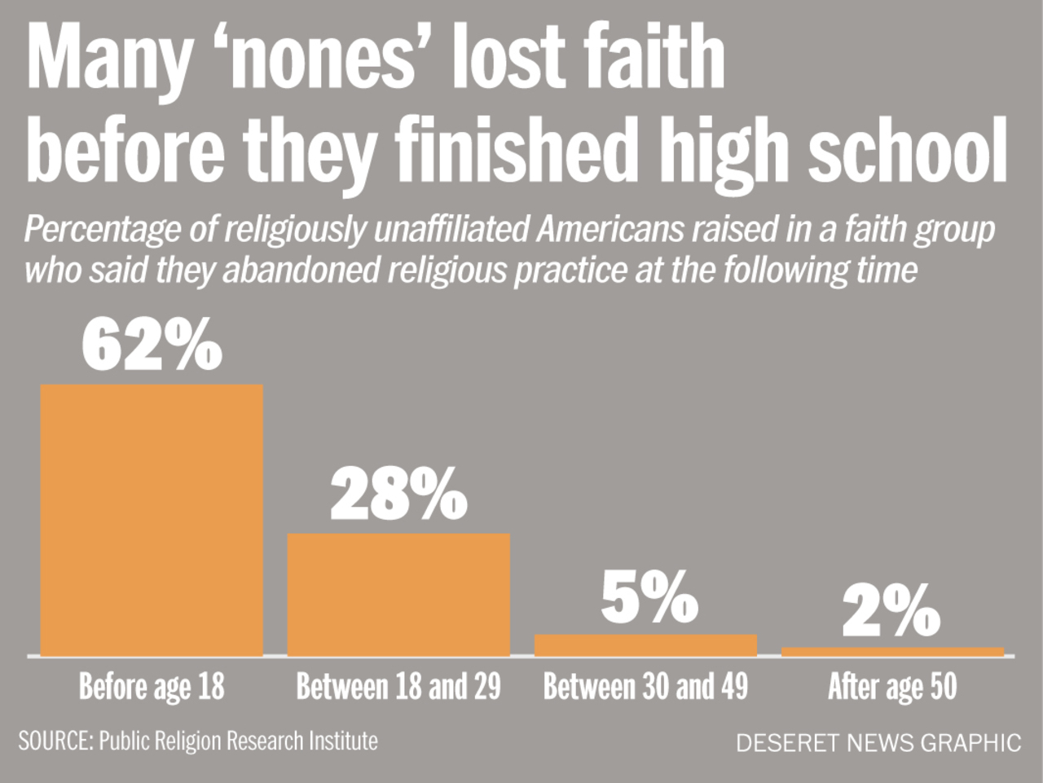

Here are other key findings from the their research:

- Leaving: Among the reasons Americans identified as important motivations in leaving their childhood religion are: they stopped believing in the religion’s teachings (60%), their family was never that religious when they were growing up (32%), and their experience of negative religious teaching about or treatment of gay and lesbian people (29%).
- Divorce: Americans who were raised by divorced parents are more likely than children whose parents were married during most of their formative years to be religious unaffiliated (35% vs. 23% respectively).
- Religiously Mixed Household: Americans raised in mixed religious households—where parents identified with different religious traditions—are more likely to identify as unaffiliated than those raised in households where parents shared the same faith (31% vs. 22% respectively). This is especially true for Catholics: in religiously mixed families 39% remain Catholic vs. 66% of those raised in Catholic households by parents who were both Catholic.
- Rise of Religiously Unaffiliated Households: A majority (54%) of unaffiliated Americans who are married today report that their spouse shares the same religious background as they do.

They identified three distinct groups among the unaffiliated: Rejectionists, Apatheists, and Unattached Believers:

- Rejectionists (58%) say religion in not personally important in their lives and believe religion as a whole does more harm than good in society.
- Apatheists (22%) say religion is not personally important to them, but believe it is more socially helpful than harmful.
- Unattached Believers (18%) say religion is important to them personally.

In Belief without Borders: Inside the Minds of the Spiritual but not Religious, Linda Mercadante conducted in-depth interviews with a cross section of the Spiritual But Not Religious (SBNR). She organized the SBNRs into five types:

- Dissenters are people who largely stay away from institutional religion. Some are “protesting dissenters” who are hurt, offended, or angry with organized religion; while others “drifted dissenters,” those who simply drift out of organize religion and never go back.
- Casuals are people whose religious or spiritual practices are primarily functional, i.e., a given practice, teaching, or guide helps them feel better.
- Explorers are like spiritual tourists who enjoy the journey but do not plan to settle anywhere. Some explorers occasionally attend traditional or alternative services. Theologically, they are hybrids, mixing and matching seemingly disparate beliefs, techniques, and spiritual practices.
- Seekers are searching for a spiritual home. Some contemplate reclaiming earlier religious identities, moving on to something slightly different, or joining a completely new religion or alternative spiritual group.
- Immigrants have moved to a new spiritual “land” and are trying to adjust to this new identity and community. Adopting a new religion requires commitment, constancy, and group loyalty, characteristics that vie with the SBNR ethos (independence, freedom, non-dogmatism, and an open and questing attitude). Many people could not take the strong disjunction from their native upbringing and eventually dropped out. “Surprisingly often, the source of their discomfort was theological. A religious or spiritual group often makes certain belief assumptions these newcomers found difficult to fully embrace, even with much effort” (Mercadante 2014, 64).

Symposium 2017: Faith Formation with a New Generation
Generation Z / iGeneration & the Parents

Insights from: Generation Z Goes to College

Corey Seemiller and Meghan Grace (Jossey Bass, 2016)

Key Insights
- 9/11, economic recession, war, and high unemployment rates have impacted their lives.
- Their phone has taken the place of video games, paper, music player, etc.
- Goal: to find solutions to world’s problems.
- Characteristics: loyal, compassionate, thoughtful, open minded, responsible, determined.

Motivation and Beliefs
- 70% are motived by not wanting to let others down, motivated by awards (advancement or earning credit, rather than tangible gifts).
- Information about anything is literally at their finger tips.
- 24/7 communication/connection (online shopping, video and music streaming, email, etc.)
- FOMO (Fear Of Missions Out).
- Creative workspaces and entrepreneurship (Google, eBay, Uber, Airbnb, etc.).
- Disaster and tragedy (9/11, mass shootings, Hurricane Katrina, SARS, Ebola, etc.).
- Diversity and social justice.
- Socially liberal and politically conservative.

Friends, Family, and Romance
- Gen Z students prefer friends they can relate to.
- Shared values and shared hobbies are the most important factors for making friends and sustainable relationships. They find it important to live near friends unlike previous generations.
- 88% of Gen Z feel they are extremely close to their parents and see them as sources of
- emotional and financial support. And take opinions and perspectives of their family into their decision making
- Online dating is the new norm. No longer need to be in the right place at the right time when you can view limitless profiles and “swipe to the right.”

Insights from: Marching Off the Map

Tim Elmore with Andrew McPeak (Poet Gardener, 2017)

Terms that summarize them:
- Instant Access: They have a Google reflex, and can find answers now. No waiting.
- New Normal: They grew up with terrorism, recession, and other common hardships.
- On Demand: They expect entertainment when they want it and they can’t stand boredom.
- Multi-cultural: They’re a mix of ethnic races; 50 percent increase in this identity since 2000.
- Immediate Feedback: They insist on responses from social media, games, or friends.
- Constant Contact: They’re always connected, with few margins for solitude or silence.
- Blended Family: They are used to new definitions of family, identity, and sexuality.
- Anything Goes: They grew up at a time when traditional morals are in question.

Seven major shifts as Generation Y (Millennials) becomes Generation Z:
- Confidence is morphing into caution.
- Idealism is morphing into pragmatism.
- Attacking an education is morphing into hacking one.
- Spending money is morphing into saving money.
- Consuming media is morphing into creating media.
- Viral messages on social media are morphing into vanishing messages.
- Text messaging is morphing into iconic messaging.

Characteristics:
- Realistic: They tend to be more realistic not idealistic, seemingly jaded from the tough economy, terrorism and complexities of life.
- Private: They don’t want to be tracked in social media. Apps like Snapchat and Whisper have seen explosive growth in the last few years. In contrast, Facebook has lost 25 percent of this demographic since 2011.
- Entrepreneurial: These students plan to be pioneers, not merely settlers in a career. 72% of current high school students want to start a business. They feel like hackers, not slackers.
- Multi-tasking: They prefer to be on 5 screens at once, not 2 screens like Millennials. Get ready to communicate to them while they look around, not into your eyes.
- Hyper-aware: They experience 4D Thinking. Because their minds are streaming in so many directions, they’ve become post-moderns who are hyperaware of their surroundings.
- Technology-reliant: Teens put technology in the same category as air and water. They cannot imagine living without being connected all the time.
- Open-minded: They have the ability to consider new perspectives and ideas.
- Overwhelmed: One theme that keeps showing up in research about Gen Z is the amount of diagnosed anxiety and depression they deal with at a very young age.
- More individualistic: They emphasize individuality and can be isolated.

Insights from: iGen: Why Today’s Super-Connected Kids Are Growing Up Less Rebellious, Less Happy—and Completely Unprepared for Adulthood.

Jeanne Twenge. (Atria Books, 2017)

- iGen teens are less likely to go out without their parents. They are less likely to experience the freedom of being out of the house without their parents.
- iGen teens are less likely to date.
- iGen teens are less likely to have sex than teens in previous generations. The teen birthrate is at an all time low.
- iGen teens are getting their driver’s license later (1 in 4 do not have a driver’s license at graduation).
- iGen teens are spending less time on homework, paid work, volunteering, and extracurricular activities.
- iGen teens are growing more slowly into the adult activity of drinking alcohol.
- iGen teens are safer than ever. They are concerned about their physical and emotional safety. And tend to be more risk averse—avoiding risk and danger.
- iGen teens are growing up slower—they are following a slow life strategy, common in times and places where families have fewer children and cultivate each child longer and more intensely.
- iGen teens are entering college and the working world without as much as experience with adult independence (like having a paying job, driving a car, dating).
- iGen teens are more individualistic (as is American culture) with the consequence that it takes longer and longer to enter adulthood—work and family roles.
- iGen teens spend about 17 hours a day in school, sleeping, and on homework and school activities. Nearly all of their leisure hours are spent with new media. 12th graders spend their screen time Texting (28% of the time), Internet (24%), Gaming (18%), TV (24%), Video Chat (5%).
- iGen teens overwhelming use social media sites: 97% of 12th graders use social media sites of which 87% of girls and 77% of boys use social media sites almost every day. iGen teens communicate electronically using Instagram, Snapchat, and texting. Online friendship is replacing offline friendship.
- iGen is spending less time with their peers face-to-face. The number of teens who get together with their friends every day has been cut in half in just 15 years. They are less likely to take part in face-to-face social activities: small group or one-one activities with friends, large group activities like parties, seeing a movie, going to the mall.
- iGen teens who spend more time with their friends in person are happier, less lonely, and less depressed, while those who spend more time on social media are less happy, lonelier, and more depressed. At the very least, online time does not protect against loneliness and depression, while in-person time does.

4. The Families of Gen Z: 15 Findings from Research

- There is no single family arrangement that encompasses the majority of children today. Two-parent, married couple households are on the decline.
- The overwhelming majority of mothers and fathers say that being a parent is extremely or very important to their overall identity and a rewarding experience.
- Parents are busier than even—and often “overwhelmed”—managing and balancing work, education, family life, young people’s activities, and their own personal lives. Today’s family is far more complex than in prior decades as parents deal with constant and accelerating change.
- Nearly 15 million children in America live below the official poverty level. Low-income families with children age 8 and under face extra barriers that can affect the early years of a child’s development. Parents in these families are more likely than their higher-income peers to lack higher education and employment, to have difficulty speaking English and to be younger than 25.
- Parents turn to people close to them (family and friends) for advice on raising their children. Mothers tend to have extensive support networks that they can rely on for advice.
- A large majority of parents young people say that get along well or pretty well, have fun together, and feel close to each other.
- Young people are very involved in a variety of extracurricular activities, but parents with higher income and higher education are more likely to report that their children participate in activities.
- A majority of parents—across income levels—are involved in their children’s education (talking with teachers, attending school meetings, going on class trips.)
- Parents’ biggest concerns are about the well-being and safety of their children; being bullied, struggling with anxiety of depression, being kidnapped, getting beat up or attacked, getting pregnant/getting a girl pregnant, getting shot, getting in trouble with the law.
- Parents want their children to be honest and ethical as adults, caring and compassionate, and hardworking. The top values that are important for them to teach include (in order): being responsible, hard work, religious faith, helping others, being well mannered, independence, empathy, obedience, persistence, creativity, tolerance, and curiosity.
- Parents and their children are immersed in media and the new digital tools. There is a widespread adoption of new digital technologies and mobile devices that are transforming the way parents and children relate, communicate, work, and learn. Parents can be divided into three groups based on how they limit or guide their children’s screen time with each group representing about one-third of all parents: digital limiters, digital enablers, and digital mentors.
- Generation X parents and Millennial parents have distinct parenting styles that reflect their generational experiences as well as the current world in which their children are growing up. In general Gen X parents approach child-rearing as a set of tangible practices that will keep their children safe, reasonably happy, well-behaved, and ready to take on life’s challenges. They practice protective parenting. In general, Millennial parents, reflecting their values of individuality and self-expression, focus more on a democratic approach to family management, encouraging their children to be open-minded, empathetic, and questioning—and teaching them to be themselves and try new things. They are moving away from the overscheduled days of their youth, preferring a more responsive, less directorial approach to activities.
- Generation X and Millennial parents reflect an increasing diversity in religious beliefs, practices, and affiliation. A growing number of parents and whole families are now religiously unaffiliated and/or spiritual but not religious. Twenty-three percent of Generation Xers and over thirty-four percent of Millennials are not religious affiliated and the number of unaffiliated Millennials is growing.
- Families of Generation X and Millennial parents are participating less in church life and Sunday worship. Parents may bring their young people to educational programs and milestone celebrations (first communion, confirmation), but they are not participating in Sunday worship or other church activities. Religion and spirituality may be important to families today, but for many it is not usually expressed by participation in churches.
- Generation X and Millennial parents are providing religious socialization and religious transmission in declining numbers. Significant indicators, such as religious identification as a Christian, worship attendance, marriages and baptisms in the church, and changing generational patterns, point to a decline in family religious socialization across all denominations. There is also a decline in religious traditions and practices at home. Gen X and Millennial parents often lack the religious literacy and religious experiences necessary for faith transmission. Many did not grow up in families where they experienced religious traditions and practices. Many were away from a church for ten or more years before returning with their children for baptism or the start of Sunday school or first communion. They lack the fluency with the Christian faith tradition or the confidence to share it with their children.
Symposium 2017: Faith Formation with a New Generation
Forming Faith in the Intergenerational Community

Becoming Intentionally Intergenerational

Bringing generations together within the church provides benefits and blessings on a variety of levels. Insights from research and pastoral experience tell us that being intentionally intergenerational:

- reclaims God’s intent for faith to be shared in community and across generations
- affirms each person’s value in the total community (regardless of age)
- fosters a foundation of support of each other’s concerns, interests, and activities
- provides “up close and personal” formation in faith as children, teens, young adults, middle-aged adults, and older adults engage in sharing faith, teaching, learning, and praying for one another
- teaches us to care for one another
- provides role models for children and youth
- teaches us to value older adults
- allows us to pass on the traditions of family and faith
- enhances people’s identification with their congregation and integration within the community
- encourages greater faith in all generations
- creates special relationships between adults and youth
- fosters leadership regardless of age or stature
- utilizes the strengths (the wisdom, experience, and knowledge) of one generation to meet the needs of another generation
- promotes understanding of shared values and respect for individuals in all stages and ages of life
- utilizes the creative talents of younger and older generations to provide service to the church and community

Becoming intentionally intergenerational provides opportunities to:

- Form and deepen Christian identity and commitment as people develop relationships and actively participate in faith communities that teach, model, and live the Christian tradition and way of life.
- Provide a curriculum for the whole community—Sunday worship, the lectionary and church year seasons, learning, service, ritual and sacraments, prayer, and more—that is a shared experience in faith and belonging for everyone.
- Strengthen relationships, connections, and community across generations; enhance their sense of belonging in the faith community; and provide valuable adult role models for children and adolescents.
- Support families by surrounding them with a community of faith and engaging the whole family in a variety of faith-forming experiences together (caring relationships, celebrating, learning, praying, serving); and providing parents with opportunities to learn from Christians who are practicing their faith and raising faithful children.
- Strengthen the ability (confidence and competence) of parents and grandparents to promote religious socialization at home; be role models of faithful practice; and engage in faith practices at home and develop warm, affirming, and unconditionally supporting relationships between parents (and grandparents) and their children, teens, and young adults.

1. Utilize

Utilize the intergenerational events and experiences of church life (worship/lectionary, seasons of the year, service/mission actions, prayer, etc.) the primary “content” and experiences for faith formation in intergenerational programs or age-group programs. Use a three step process:

- Prepare people—intergenerationally or in age groups—with the knowledge and practices—for participating in a church event.
- Experience/participate in the intergenerational church event or experience.
- Reflect upon the meaning of the event and discover how to live/practice that learning in daily life (with online activities and resources.

For example:

- People learn about worship and how to worship in intergenerational settings or age groups; experience Sunday worship with the faith community and practice worshipping; and live the Sunday worship experience at home and in their daily lives (with activities and resources delivered online).
- People learn about the justice issues of our day and the biblical and church teachings on justice, service, and care for creation in intergenerational settings or age groups; experience acts of justice and service with the faith community—locally and globally; and engage in the practices of serving those in need, caring for creation, and working for justice—as individuals, with their peers, with their families, and with their church and other groups and organizations.
- People would learn about the Bible and how to read it, interpret it, and apply it to their lives; experience the Bible at Sunday worship and at home; and develop their own practice of Bible study and reading.
- People would learn about Jesus and the Christian tradition—teachings, history, practices, what it means for life today, and how to live the Christian faith today; and experience the life of Jesus and the Christian tradition through participation in the events of church life, especially church year feasts and seasons.
- People would learn about prayer and spirituality and how to develop their spiritual lives through prayer and spiritual discipleship; experience the prayer life of the faith community; and develop their own practice of prayer and the spiritual disciplines.

2. Connect & Infuse

Connect the generations through new activities and/or Infuse intergenerational experiences and relationships into existing ministries and programs. For example:

- Incorporate intergenerational dialogues into programming.
- Develop mentoring relationships (prayer partners, spiritual direction, service involvements, confirmation mentors)
- Link people of different generations who have insights and life experiences that may be helpful to other generations (midlife and older adults helping young adults and new parents with financial management and household management, or young people helping older adults navigate the digital and online world).
- Involve the community in praying for a generation (on a mission trip or retreat weekend, celebrating a milestone, such as the birth of a child, marriage, graduation, retirement).
- Organize social and recreational activities that build intergenerational relationships.
- Sponsoring community-wide service projects that engage all ages
- Include other generations in current age-group programs, such as mission trips, service projects, retreat experiences, vacation Bible school, etc.
- Developing specific roles for the younger generations in church leadership, such as adolescents serving as teachers in children’s faith formation or as worship leaders.
- Organize a leadership or ministry apprenticeship for younger generations to serve in church ministries and leadership positions.
- Sponsor music and art projects such as a community concert where musicians of all ages perform together, or an intergenerational art exchange or exhibit, or an Advent or Lent music festival.
- Organize social and recreational activities that build intergenerational relationships, such as an intergenerational Olympics, a Friday night simple meal during Lent, or a summer film festival (maybe outdoors on a large screen).

3. Create

Create new intergenerational programs and experiences that bring together all of the generations for learning, celebrating, praying, reading the Bible, serving and working for justice, and worshipping.

Intergenerational Learning

One model of intergenerational learning begins with an All Ages Learning Experience (intergenerational); moves to an In-Depth Learning Experience (age-specific or intergenerational) taught in one of three formats: age group, whole group or learning activity centers; and concludes by Sharing Learning Reflections and Preparing for Practice (intergenerational).

- Gathering and Opening Prayer
- All-Ages Learning Experience. Intergenerational learning begins with a multigenerational experience of the theme that all the generations share together.
- In-Depth Learning Experience. Through structured learning activities each generation—families with children, adolescents, and adults—explores the biblical and theological understanding of the topic, using one of three possible formats:
- The Age Group Format provides parallel, age-appropriate learning for groups at the same time. Though age groups are separated, each one is focusing on the same topic—utilizing specific learning activities that are designed for their life cycle stage: families with children or children alone, adolescents, young adults, and adults.
- The Whole Group Format provides a series of facilitated learning activities for everyone at the same time using intergenerational or age-specific small groups or table groups.
- The Learning Activity Center Format provides structured intergenerational and age-specific learning activities at a variety of stations or centers in a common area.
- Sharing Learning Reflections and Application. In intergenerational groups participants share what they learned and prepare for applying their learning to daily life using resources and activities provided in print or online.
- Closing Prayer Service

Ideas for Intergenerational Learning
- Develop a faith formation curriculum for the whole community using intergenerational faith formation as the primary learning model.
- Extend a topic featured in the faith formation program for children or teens, to the whole community through intergenerational learning.
- Replace a topic in the children or teen program with intergenerational learning on the same theme.
- Add intergenerational learning to sacramental preparation and celebrations.
- Conduct intergenerational faith formation before liturgical year feasts.
- Add intergenerational learning to a vacation Bible school, camp, or summer program. Design an intergenerational VBS or camp or summer program—all ages or grandparents and grandchildren.
- Conduct intergenerational learning for justice issues and action projects.
- Sponsor an intergenerational retreat for the whole community.

Milestones

Milestones are significant moments in life’s journey that provide the opportunity for people of all ages to experience God’s love, and grow in faith through sacred and ordinary events both in the life of the congregation and in daily life. Faith formation around milestones, sacramental celebrations, and life transitions provides another way that congregations can be intentionally intergenerational—engaging the whole community in the celebration of the milestone, promoting the spiritual and faith growth of all ages, enhancing family faith practice at home, and strengthening people’s engagement in the church community.

Congregational milestones include: baptism, welcoming young children to worship, first communion, presentation of Bibles, confirmation, marriage, a funeral, sending people on mission trips, and much more. Lifecycle milestones include: entering a new stage of schooling, graduations (middle school, high school, college, or graduate school), getting a driver’s license, leaving home for college or the military, first home or apartment, new career or job, moving, retirement, death of a family member, and much more. Annual milestones include birthdays, anniversaries, start of the school year (e.g. blessing backpacks), seasons of the church year (Advent, Christmas, Lent, Holy Week), and much more.

Each milestone incorporates intergenerational components at home and church: 1) a ritual celebration or a blessing marking the milestone with the whole church community; 2) a home ritual celebration or blessing marking the milestone; 3) a learning program, for the individual and the family, that prepares them for the milestone and its significance for their life and faith; 4) a tangible, visible reminder or symbol of the occasion being marked, given by the church community; and 5) people and resources to support continuing faith growth and practice after the milestone.

Intergenerational Service

Intergenerational service provides many benefits to individuals, families, and the whole church community. Intergenerational service helps narrow the generation gap between older and younger church members; recognizes that all people in the church, regardless of age, have talents to contribute that are valuable and important; assists children and youth in feeling a part of the church today, not just the church of tomorrow; connects the generations and builds relationships as they serve God by serving their neighbor; communicates that it is the responsibility of all Christians, regardless of age, to serve people and work for justice as a follower Jesus Christ.

Churches can incorporate intergenerational service into existing service projects and activities and create intergenerational versions of an existing program. Almost any service project can become intergenerational. For example:

- Offering mission trips for adults and young people.
- Connecting youth with adults in the church who already preparing and serving meals at a soup kitchen or homeless shelter.
- Engaging children, parents, and older adults in collecting and delivering food baskets, school kits for children, “personal essentials” for those at a homeless shelter, toys at Christmas, gift packages for prisoners, and so on.
- Involve families in caring for the elderly by visiting them at a convalescent home or senior citizen facility or doing chores and shopping.
- Supporting efforts to provide vaccines and medical care to the world’s poor, such as mosquito nets for malaria prevention and immunizations against childhood disease.
- Conducting a church-wide or community-wide intergenerational fundraising project to a) support the efforts of local and national groups who work directly with the poor, b) adopt a community in another country by supporting them financially and learning about their culture and community life, or c) support organizations that are building schools and libraries for children in the poorest countries of the world by providing books and/or our money to purchase books for children.
- Develop intergenerational justice teams to advocate for just policies and priorities that protect human life, promote human dignity, preserve God’s creation, and build peace by 1) becoming familiar with pending legislation or proposals that affect people’s basic needs, 2) writing advocacy letters or emails, 3) working with advocacy groups, and/or 4) working with organizations that are changing the structures that promote injustice.
- Holding a fair trade festival to provide a way for people to buy fair trade products, such as coffee, chocolate, and crafts, that benefit local producers in the developing world.
- Sponsoring a community-wide “care for the environment day” by planting trees and cleaning-up the community

Connecting, Infusing, and Creating Worksheet

Caring Relationships & Community
- How can you CONNECT generations at church, at home, and in the community using the opportunities that already exist and developing new ways to connect generations?
- How can you INFUSE intergenerational relationship building into current congregational ministries, programs, activities, and experiences?
- How can you CREATE new intergenerational programs, activities, and experiences that create caring relationships across generations?
Celebrating Worship, Seasons, Rituals
- How can you CONNECT generations through Sunday worship, seasonal celebrations, and milestone rituals (before, during, and after worship and celebrations)?
- How can you INFUSE intergenerational relationship building into Sunday worship, seasonal celebrations, and milestone rituals (before, during, and after worship and celebrations)?
- How can you CREATE new intergenerational worship, seasonal celebrations, and milestone rituals that bring all of the generations together or TRANSFORM existing worship, seasonal celebrations, and milestone rituals into intergenerational experiences?
Learning
- How can you CONNECT generations through current educational programs offered by the church?
- How can you INFUSE intergenerational learning into current educational programs, such as age-group programs, vacation Bible school, retreats, service projects, milestone and sacramental learning experiences, preparation for church year seasonal celebrations, and more?
- How can you CREATE new intergenerational learning programs and experiences for the whole faith community or TRANSFORM existing age-group programming into intergenerational learning programs, such as intergenerational vacation Bible school.
Praying & Spiritual Formation
- How can you CONNECT generations through the prayer life of the congregation and spiritual formation programs and experiences?
- How can you INFUSE intergenerational relationship building and experiences into the prayer life of the congregation and spiritual formation programs and activities?
- How can you CREATE new intergenerational prayer experiences and spiritual formation programs that bring all of the generations together or TRANSFORM existing prayer and spiritual life activities into intergenerational experiences?
Serving, Working for Justice, Caring for Creation
- How can you CONNECT generations through the congregation’s service and mission to the community/world, and through it’s age-specific service and mission projects.
- How can you INFUSE intergenerational relationship building and experiences into the congregation’s service and mission to the community/world, and through it’s age-specific service and mission.
- How can you CREATE new intergenerational service projects and mission activities that bring all of the generations together or TRANSFORM the congregation’s current service/mission activities and age-specific service and mission projects.
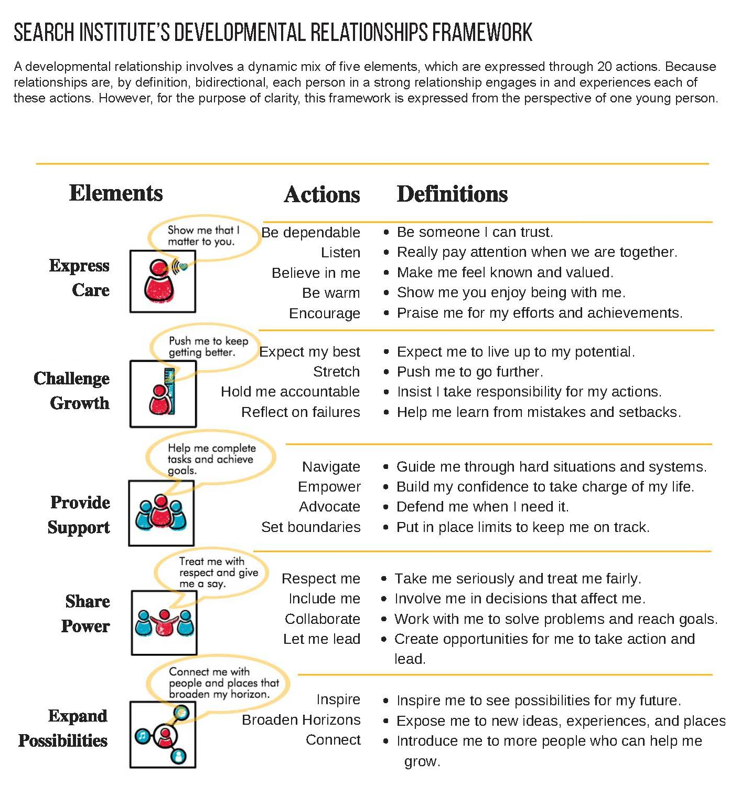
Symposium 2017: Faith Formation with a New Generation
Forming Faith in the Family

Families & Faith

Key Faith Factors

- Parents’ personal faith and practice
- Parent-child relationship: close and warm
- Parents’ modeling and teaching a religious faith
- Parents’ involvement in church life
- Grandparents’ religious influence & relationship
- Religious tradition a child is born into
- Parents of the same faith
- Family conversations about faith
- Embedded family religious practices: praying, reading the Bible, serving, celebrating holidays and rituals

Religious Parenting
(From A Report on American Catholic Religious Parenting. Justine Bartkus and Christian Smith.
University of Notre Dame, 2017)

- The crucial location where youth’s religious outcomes are largely decided is not the congregation or the parish, but the home.
- The primary mechanisms by which Catholic identity becomes rooted in children’s lives are not Catholic schooling or sacramental preparation, but rather the day-to-day religious practices of the family and the ways parents model their faith and share it in conversation, collaboration, and exposure to outside religious opportunities.
- This is all to say that the definitive causal agents in the religious and spiritual outcomes of American youth are neither clergy nor youth ministers, neither educators nor the voices of popular culture and media, but parents.
- The single most powerful force in a child’s religious formation is the spiritual personality of the parent.
- Effective transmission of the Christian faith is completely possible for parents who genuinely intend this goal.
- Parents by the power of their personality, practices, and way of being, model and generate the culture of the household (both explicitly and implicitly).
- Parents produce, induce, and interpret the household’s experiences of Christian faith.
- Parents are one influence among others - they are nevertheless the dominant influence which orders and shapes the way children experience other influences, i.e. they constellate children’s experiences of various cultural currents, including religion..
- Both parents and churches need to understand the cultural and psychological centrality of parents’ role in religious transmission.
- The faith of the household is a common fund from which all draw freely. To be effectively handed on to children, such faith cannot be perceived as “belonging” only to parents, even if parents must often coerce children into participating in religious activities.

One of the most basic suggestions of our findings is that young adults arrive at a sense of their fundamental identity and worldview not by weighing all possible intellectual arguments for and against a proposed way of life, but rather by roughly adopting the worldview of those mentors who left the deepest impression upon them—and who loved them and cared for them the most. It should come as no surprise, then, that the emergence of the new generation of dedicated young Catholics will rise and fall with the choices of their parents.

Three Primary Roles in Transmitting Religion
(From A Report on American Catholic Religious Parenting. Justine Bartkus and Christian Smith.
University of Notre Dame, 2017)

1. Sponsor of the Catholic Faith
Parents are the point of access between the Church and their children. To differing degrees, neighborhoods, ethnicities and mainstream cultural attitudes toward religion have all declined as cultural “carriers” of Catholic belief. If children are not initially exposed to the Catholic faith by their parents, they usually will not be exposed to it at all.

2. Gatekeeper of the Catholic Faith
Parents have nearly total control over how much and what sorts of religious content their children encounter—whether children attend Catholic school; whether prayer, reading the Bible, or receiving
Communion and going to Reconciliation will occur regularly in their lives; whether they will be exposed to relationships and communities that have a religious dimension, and so forth. Parents are thus the “gatekeeper” of religious content for their children. To use another metaphor, parents are like a faucet, determining whether religious content will arrive in children’s lives at an occasional drip or in a regular flow.

3. Interpreter of the Catholic Faith
Parents do not act as a neutral medium, a mere channel, between Catholicism and their children. Rather, they are definitive role models, mentors, who embody a specific manner of being Catholic. They teach children how to apprehend the world, how to understand what is good and what is evil, how one ought to affectively, intellectually and practically engage with the world, and so on. They do not just “represent” the faith; in many cases, they are the only meaningful embodiment of that faith in the lives of children. Parents render faith a matter of flesh and blood rather than a lifeless mishmash of doctrines and teachings. If children do not “see” Catholicism in the “face” of their parents, they will likely never gain sufficient familiarity with it to commit to practicing the faith in the long run.

As “sponsors,” “gatekeepers,” and “interpreters” of the Catholic faith for their children, parents give
children a glimpse of what Catholicism seems to be all about and whether or not it can meaningfully inform one’s day-to-day life.
Because parents’ commitment to practice and transmit Catholicism in the household is so demonstrably different from mainstream American culture, we found that those parents who embraced the three roles listed above were the ones who succeeded in transmission. They understood religious transmission to be a holistic, foundational household commitment of high priority rather than simply as one aspect of life alongside others. Successful parents were more likely to express how unimaginable and untenable family life would be without religion; their homes were more replete with visible religious art, and they had little difficulty reporting meaningful conversations and common experiences among the family that related to religion. By contrast, those parents who were less successful in transmission described households with a thinner religious atmosphere. It is not that these parents did not intend or desire to transmit their Catholicism, but rather that their aspirations did not translate into the establishment of a vivid Catholic culture in the home.

Ultimately, the decisive question our interviews suggested to us was this: had children been initiated
into a cultural worldview where they perceived that being Catholic mattered, where faith had been so
thoroughly and convincingly modeled, lived and shared that children either perceived no alternative to embracing Catholicism, or far preferred being Catholic to any other path? Had children been initiated into a lived template for carrying on a Catholic way of life, for navigating the twists and turns of growing up with their faith as a guiding resource?

One of the most basic suggestions of our findings is that young adults arrive at a sense of their fundamental identity and worldview not by weighing all possible intellectual arguments for and against a proposed way of life, but rather by roughly adopting the worldview of those mentors who left the deepest impression upon them—and who loved them and cared for them the most. It should come as no surprise, then, that the emergence of the new generation of dedicated young Catholics will rise and fall with the choices of their parents.

Unaffiliated Parents Raising their Children Religiously

In her book Losing Our Religion: How Unaffiliated Parents Are Raising their Children Christel Manning presents her research into the worldviews that are included within the term “None” and how those beliefs are reflected or not reflected in the way parents raise their children. She identifies four distinct worldviews among unaffiliated parents: Secular (believes there is no God that influences the world or human life), Seeker Spirituality (believes there is no God but there is a higher power or life force), Unchurched Believer (believes in a personal God who listens and can intervene in human affairs; and prays or attends services), and Indifferent (no beliefs or practices). She identifies five different strategies that parents use to incorporate religion in the lives of their children.

- Nonprovision: These are parents who do not incorporate religion into their children’s lives. They do not intentionally include religion or spirituality in the home life (no “God talk,” religious books, meditation or prayer; holidays are cultural; religious meaning is not explained); do not enroll the child in institutional religious or alternative worldview education programs; and remain unaffiliated.

- Outsourcing: These are parents who rely on other people to incorporate religion into their children’s life. They do not intentionally incorporate religion or spirituality in the home, enroll the child in formal program like CCD or Hebrew school or Sunday school, and decline to become members of that religious institution. There was a common theme: they felt a duty as a parent to provide religion, regardless of their personal ambivalence about it, because their child “had a right” to this information. Sometimes this was because religion (usually Judaism or Catholicism) was a family heritage; sometimes because it reflected an interest/inclination of their child.

- Self-provision: These are parents who try to incorporate religion into their children’s upbringing without institutional support. They remain unaffiliated, do not enroll their child in formal religious education program, and intentionally incorporate religion or spirituality into home (talk to child about God or higher power; pray or meditate with child, read religious stories; incorporates religious or spiritual explanations into holidays).

- Alternative: These are parents who were unaffiliated before they had children and reported searching for and eventually affiliating with an organization that welcomes doubters and the nonreligious such as the Unitarian Universalist Association (UUA) or the American Humanist Association (AHA). They enroll their child in a “worldview education” program, which typically teaches children about many different religions, rather than socializing them into one of them; intentionally incorporate religion/spirituality in the home but do so in consciously pluralistic way, for example, by combining imagery from both Buddhism or Judaism, or celebrating the holidays of various religions; or, over time, is led by having children to affiliate with a community that they perceive as tolerant of being nonreligious.

- Traditional: Some unaffiliated parents decided to return to the religion they were raised in and enroll their child in a conventional religious education program (CCD, Sunday school, or Hebrew school). Parents are Traditional if having children leads them to return to the community they were raised in and re-affiliate, a child is enrolled in conventional religious education program, and they incorporate religion in the home.

Manning found that in most cases, there was a great deal of consistency between the parent’s religious or secular identity and how they raised their children. She observes, “the fact that most parents in the study took steps to incorporate religion into the lives of their children is surprising only if we take None to mean the absence of any religious, spiritual, or philosophical worldview. Once we discover the more substantive dimensions of unaffiliated parents’ worldviews, we see that they transmit those beliefs and practices to their children much as affiliated parents do.”

Family Faith Formation Strategies

- Discovering God in Everyday Life: guiding families to reflect on God’s presence in their daily life
- Forming Faith at Home through the Life Cycle: equipping and resourcing families to practice their faith at home through prayer, devotions, reading the Bible, rituals, milestone celebrations, service, learning, and more (with activities and resources delivered online)
- Forming Faith through Milestones: celebrating one-time milestones and annual milestones through experiences at home and in the congregation that activities of naming, equipping, blessing, gifting, and reinforcing (with activities and resources delivered online)
- Celebrating Seasonal Events through the Year: celebrating church year seasons and calendar seasons at home, at church, and in the community (with activities and resources delivered online)
- Encountering God in the Bible through the Year: reading and studying the Bible through Sunday worship and the lectionary, learning experiences, and at-home devotions and reading (with activities and resources delivered online)
- Connecting Families Intergenerationally: developing intergenerational programs and experiences that engage families with other generations through learning, service, community life.
- Developing a Strong Family Life: cultivating a strong family life and strengthening developmental relationships through parent programs, whole family programs, family mentors, life cycle support groups, and online activities and resources.
- Empowering Parents and Grandparents: developing parenting competencies and skills, promoting the faith growth of parents, and developing the faith forming skills of parents.

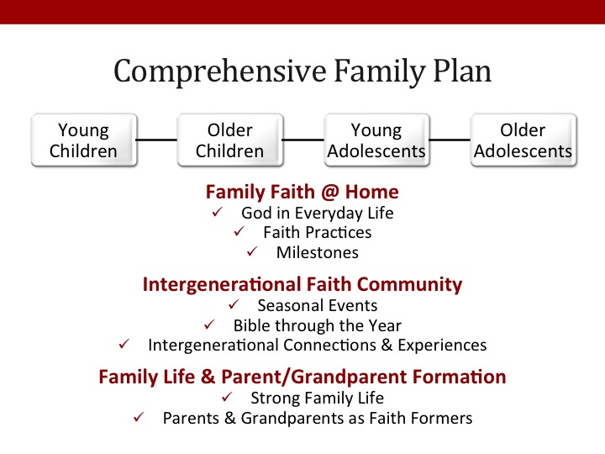

Family Faith Practices

- Praying as a family (meal time, bedtime)
- Praying as a family during times of struggle or crisis
- Encouraging teens to pray alone or with peers
- Reading the Bible as a family
- Encouraging teens to read the Bible alone or with their peers
- Celebrating rituals and holidays at home
- Serving people in need as a family
- Serving people in need as individuals (parents, teens)
- Eating together as a family
- Having family conversations
- Talking about faith as a family
- Watching videos, movies, or TV shows with religious content or themes
- Encouraging teens to talk about their doubts and questions about faith
- Talking about faith and your religious tradition with your children and teens
- Asking your teenager's perspectives on faith, religion, social issues, etc.
- Providing moral instruction
- Demonstrating a warm and affirming parenting approach
- Taking time to growing in your own faith as a parent
- Engaging in positive communication with children and teens
- Encouraging children and teens to pursue their talents and interests
- Spending one-on-one time with children and teens
- Participating in Sunday Worship as a family
- Inviting friends of your teen to join in family practices (Sunday worship, service, prayer)
- Celebrating the church year seasons at church (Advent/Christmas, Lent/Easter)
- Celebrating rituals and sacraments at church as a family
- Participating in church life activities as a family
- Encouraging and supporting your teen to participate in church activities with peers

Parent Practices and Skills

- Expressing care, love, affection, and support for children
- Balancing time and commitments, managing stress
- Practicing healthy relationships
- Disciplining children and learning discipline practices
- Creating a warm, caring supportive family.
- Set boundaries and high expectations for children
- Managing technology and media use
- Challenging children to grow and continuously improve
- Providing support to help children complete tasks and achieve goals
- Sharing power with children so that there voice is heard and they share in making decisions.
- Expanding possibilities and connecting children to opportunities for growth
- Developing emotional communication skills
- Developing positive parent-child interaction skills
- Learning to respond consistently to their child

Family Life Practices

- Communicating effectively
- Establishing family routines: family meals, shared activities, daily commitments
- Celebrating meaningful traditions and rituals
- Discussing tough topics
- Making decisions and solving problems as a family
- Learning how to build strong relationships and express care for each other
- Developing the strengths & potential of children & youth
- Supporting each other: encouraging and praising, giving feedback, standing up for each other
- Treating each with respect and dignity

Developing Family Faith Formation

Part 1. Family Faith at Home

Strategy: Discovering God in Everyday Life
Guiding families to reflect on God’s presence in their daily life

- What ideas or activities would you develop to implement this strategy?
- How would you reach and engage families in activities for Discovering God in Everyday Life?

Strategy: Forming Faith at Home through the Life Cycle
Equipping and resourcing families to practice their faith at home through prayer, devotions, reading the Bible, rituals, milestone celebrations, service, learning, and more

- What ideas or activities would you develop to implement this strategy?
- Celebrating the liturgical seasons
- Celebrating rituals and milestones
- Learning the Christian story and vision
- Praying and spiritual formation
- Reading and studying the Bible
- Serving and working for justice
- How would you reach and engage families in activities for Forming Faith at Home?

Strategy: Forming Faith through Milestones
Celebrating one-time milestones and annual milestones through experiences at home and in the congregation that activities of naming, equipping, blessing, gifting, and reinforcing

- What ideas or activities would you develop to implement this strategy?
- How would you reach and engage families in activities for Milestones Faith Formation?

Part 2. Family Life and Parent Formation

Developing a Strong Family Life
Cultivating a strong family life and strengthening developmental relationships through parent programs, whole family programs, family mentors, life cycle support groups, and online activities and resources.

- What ideas or activities would you develop to implement this strategy?
- How would you reach and engage families in activities for Developing a Strong Family Life?

Empowering Parents and Grandparents
Developing parenting competencies and skills, promoting the faith growth of parents, and developing the faith forming skills of parents
- What ideas or activities would you develop to implement this strategy?
- How would you reach and engage parents in activities for Empowering Parents & Grandparents?

Part 3. Families in the Congregation

Celebrating Seasonal Events through the Year
Celebrating church year seasons and calendar seasons at home, at church, and in the community

- What ideas or activities would you develop to implement this strategy?
- How would you reach and engage families in activities for Celebrating Seasonal Events?

Encountering God in the Bible through the Year
Reading and studying the Bible through Sunday worship and the lectionary, learning experiences, and at-home devotions and reading

- What ideas or activities would you develop to implement this strategy?
- How would you reach and engage families in activities for Encountering God in the Bible?

Connecting Families Intergenerationally
Developing intergenerational programs and experiences that engage families with other generations through learning, service, community life, etc.

- What ideas or activities would you develop to implement this strategy?
- How would you reach and engage families in activities for Connecting Families Intergenerationally?

Symposium 2017: Faith Formation with a New Generation
Faith Formation with Children & Youth

Children

Children’s Development
Tanya Campen

0-2 Years: Am I safe and can I trust you?  2-4 Years: What can I do? | 4-5 Years: Is it OK for me to explore?  5-12 Years: How can I succeed?
Human Development  - Need: Safe space  - Need: Purpose  - Need: Opportunities to try new things  Family Development  - Need: Caring relationships  - Need: Practice makes perfect  - Need: Explore the world together | Social and Cultural Development  - Need: Work is important  - Need: Justice seekers  Faith Development  - Need: Participate in ritual and liturgy  - Need: Engage in Story

Key Developmental Learning | Gift Children Bring | Faith Formation Process
Create Safe Space | vulnerability | Caring Relationships
Discover Purpose | helper | Rituals and milestones; serving, working for justice, and caring for creation
Try New Things | courage | Learning the tradition, praying and spiritual formation, reading the Bible, and Worshiping
Build Relationships | relational awareness | Learning the tradition; praying and spiritual formation; reading the Bible; Worshiping
Practice | play | Rituals and milestones; praying and spiritual formation; reading the Bible; and worshiping
Explore | curiosity | Church year seasons; praying and spiritual formation; caring relationships
Work | wonder | All
Seek Justice | empathy | Serving, working for justice, and caring for creation
Participate in Ritual and Liturgy | order | Rituals and milestones; learning the tradition; and worshiping.
Engage in Story | imagination | Reading the Bible; learning the tradition; worshiping
Spiritual Characteristics of Children
(© 2015 Faith Formation Ministries, 1700 28th Street S.E., Grand Rapids)

Preschoolers
- have a growing sense that God is very special and real.
- tend to have a literal concept of God, perhaps as a grandfather figure who lives “up there.”
- readily accept what you say about God.
- sense that God loves them and cares for them.
- enjoy Bible stories, especially about Jesus; want stories repeated . . . and repeated!
- can develop attitudes of trust and love toward Jesus and God.
- do not yet have a built-in control (conscience) that nudges them toward right behavior for its own sake; they generally do the “right thing” out of fear of punishment or to win approval.
- sense that church is a good place to be.
- can recite simple prayers; may add their own ideas to form personal prayers.

5- and 6-year-olds
- have a very real spiritual nature, a strong sense of who God is, and often relate to Jesus as their friend.
- are aware of right and wrong but are still likely to define “wrong” in terms of its immediate consequences (“Taking cookies is wrong if Mom catches me!”). They begin to experience guilt and understand the joy that comes with forgiveness.
- understand God’s love and our response within the context of everyday experiences and, to some extent, within the context of God’s family, the church. By and large they are still concrete thinkers.
- can be delighted and awed by Bible stories. They can use their imagination to ask questions about the Bible and God.
- can express their love for Jesus in their own words and actions.

7- and 8-year-olds
- are capable of understanding basic salvation concepts and making a commitment to Jesus, but they may do so simply out of a desire to please their teachers or parents.
- often express opinions and feelings about God and church. They enjoy asking a great many “why” and “how” questions.
- often include prayer in their daily routines. Their prayers are frequently self-centered but are sincere and offered in faith.
- often still see issues in black and white.

9- and 10-year-olds
- are developing a conscience: a personal sense of right and wrong that often expresses itself in judgments of what’s “unfair” or unjust. They may be critical of adults who appear to be insincere in their faith.
- may be able to deal, in a limited way, with moral questions in terms of motives and consequences. They are beginning to think about questions of ethics and morality in the context of love, loyalty, promises, and so on.
- may show an increasing concern for people who are hungry, homeless, or poor.
- are often open to learning about other cultures and can be more accepting of differences in others, especially if they have personal experiences with people who are different from them.
- understand why we pray and are often able to make up spontaneous prayers.
- are more inclined to look inward than younger children and may ask questions and wonder about making a commitment to Christ.

Children’s Faith Formation
Karen Marie Yust (“Being a Child, Becoming Christian” in Children's Faith Formation - Lifelong Faith Journal, www.LifelongFaith.com) (See also: Real Kids, Real Faith. Jossey Bass, 2004)

Infants and Toddlers
- Congregational Life: In order for them to see, hear, taste, touch and smell what it means to be part of a Christian community, we must invite them to participate in congregational worship and outreach. Their dependence on us requires that we practice hospitality by bringing them to church and taking them with us to food pantries, homeless shelters, and hospice rooms.

- Bible: Telling biblical stories and narratives of Christian spiritual practices, then, contributes to young children’s generation of faith memories. Overhearing Scripture read and prayers said at liturgy contributes to these memories, as does regularly hearing about God and God’s people from a children’s story Bible or the Scriptures themselves.

- Ritual: The rituals of religious communities thus hold great potential for attracting young children’s interest. Children wonder about the identity and use of common objects, and we can encourage this early form of contemplation by providing child-friendly access to items used in our religious rituals.

- Liturgical Year: The cycle of the liturgical year also offers contemplative possibilities for young children. The lighting of Advent candles, the pageantry of Palm Sunday, and the waving of red streamers on Pentecost are a break in the usual worship routine. The novelty of these events attracts children’s attention if they have been regular participants in more ordinary services of worship. This is childhood immersion in the reality of our faith, a form of contemplating who and whose we are from the inside of the Christian story.

Preschool
- Participation: We can encourage the faithfulness of preschool children by nurturing both their observational skills and their imaginative play. They need regular opportunities to witness their faith community in action, which means they need to spend time every week in worship and in the midst of a congregation’s activities. They need to hear the vocabulary and see the symbols of their faith tradition used frequently so they can identify the particular structures and practices that characterize this social system and distinguish it from other social settings in their lives. They need opportunities to explore the environment where they worship, learn, and serve, and chances to ask questions about objects used in worship and images in stained glass windows.

- Imagination: As we draw preschoolers further into the world of our faith tradition, we must appeal to their imagination by inviting them to engage in pretend play with the stories, symbols, and practices of the Christian community.

- Prayer: The practice of centering prayer is a means of taking a spiritual timeout to be with God. Younger elementary age children appreciate the simple structure of this ancient prayer practice. They are capable of selecting a simple word or phrase as a centering device and repeating that word or phrase slowly over and over again as they let their bodies relax. Another prayer form younger elementary children can embrace is pausing to acknowledge God’s presence in the world on a regular basis. This simple spiritual practice involves selecting a repetitive sound or event in one’s day and then, whenever that sound or event occurs, stopping one’s activity for a moment to take note of God’s presence. The common practice of saying grace before meals is an example of such acknowledgement, but practicing the presence of God is best extended to encompass other elements of the child’s day.

Grade School
- Bible: We ask older elementary children to dialogue with the Bible by using three different types of questions in relation to faith stories. We ask clarifying questions, which focus the child’s attention on the biblical text itself. Who are the characters in the story? What happens in the beginning, middle, and end of the story? We also ask experiential questions, which invite children to relate the story to their contemporary experiences. How are the characters in this story like you or someone you know? If Jesus was going to talk with people who are social outcasts at your school, who would they be? We pair these two modes of inquiry with a third approach: responsive questions, which ask children to consider how the story might transform their lives and inform their beliefs and actions. These questions invite children to live out faith stories in their own lives, to become the embodiment of the Scriptures in their interactions with others.

- Experiential: Children ages nine to twelve continue to enjoy and require experiential learning opportunities. They can identify basic characters and plot movement by sketching out individual scenes from a biblical story on newsprint and then putting the scenes in order, or by writing dramatic scripts based on careful research into the people and historical period of the story. They might translate the story into contemporary times through skits, comic strip creations, or links to popular music or culture. Their response explorations might involve participating in outreach activities, composing intercessory prayers, developing blessing rituals, or covenanting in worship to hold one another accountable to personal and communal commitments.

- Lectio Divina: The ancient contemplative practice of lectio divina, or holy reading, is also a helpful spiritual discipline to introduce to this age group. Because older elementary children’s primary learning systems are skewed toward scientific modes of reasoning, they need the balance of a more mystical approach to learning to prevent them from equating religious belief solely with right doctrine. As a companion experience alongside critical study of the Bible, this contemplative encounter with Scripture helps remind children that God’s wisdom comes through both study and prayer.

Adolescence

Discipleship in Adolescence
(Spirit and Culture of Youth Ministry, EYM 2010)

One could sum up the purpose of the Exemplary Youth Ministry congregations’ youth ministries in a single goal: making disciples of Jesus Christ. These congregations focus their youth ministries on Jesus Christ and engage young people in discipleship, witness, and service that transforms their lives. Several “marks and means” of discipleship emerge in the study. These elements describe the core attributes of the congregations, their youth ministries, and their young people.

- Disciples Know Jesus Christ: Discipleship is grounded in the teachings, life, death, resurrection and Lordship of Jesus Christ alive and present. Disciples are in relationship with Christ, learn about Christ and follow Christ’s leading. In the vast majority of congregations in the study, youth ministry is consciously designed to cultivate a relationship with Jesus Christ through worship, prayer, community-building, study, retreats, and service.

- Disciples Know the Bible: Discipleship is anchored in Bible study. It is in the Bible that youth learn the story, the truth that shapes the life of faith. Bible studies take many shapes and forms. Most popular are small group conversational explorations of the Scripture texts in which youth and their leaders “hear” God speaking truth to their lives.

- Disciples Know the Christian Faith: Discipleship is learning the Christian faith. The Christian faith has a history, traditions, beliefs and values that are critical to its shaping and transforming power. Congregations are committed to teaching young people the content of the Christian faith through a variety of ministry experiences. Adult leaders guide young people in exploring the long and rich life of the people of God, creating more sturdy beliefs, engaging the tough questions, and assisting youth in finding their own “faith voice.”

- Disciples Make Faith a Way of Life: Discipleship is the “knowledge of faith” becoming a way of life. Discipleship is regularly described as much in languages of the “heart” and the “hands” as of the “head.” For the congregations in the study, it was not enough for young people to know the content of Scripture or to understand the richness of Christian beliefs. Whether small or large these churches developed expansive ministries with youth for the purpose of participating in faith as a way of life. The adults and youth in these ministries seemed to be “living into” faith that is simultaneously centered in God yet genuinely their own. They spoke about what they believed with conviction and in fresh language. Compassion, honesty, respect, integrity, service to others and justice were evident in their speech, life styles and relationships with others. All this was carried on with an eye on both tradition and experience; text and context; faith and life.

- Disciples are Mentored: Discipleship is formed in relationships with mentoring individuals and communities. Even though discipleship is primarily a faith-relationship in which Christ is at the center, adolescent disciples are formed in relationship with other Christians. Whole congregations become intergenerational crucibles in which conversation, relationships and practices wrap youth in a culture of “knowing and doing God.” Within these congregations, people walk intentionally and directly along side young people providing diverse, concrete “snapshots” of following Jesus Christ as these mentors encourage and teach through their presence, speech and action.

- Disciples are Equipped: A young person’s strengths and gifts of the Spirit are integral to discipleship. To follow Christ involves a call to witness and to serve others. To make disciples is to identify a teenager’s spiritual gifts and equip that teenager for service in the church and the world. Congregations combine study, fellowship, personal strengths and spiritual gifts discovery with service to equip young disciples to follow Jesus Christ in the church and into the world.

Young Adolescents
Mary Lee Becker (“Goldilocks in Our Midst: Ministry with Young Adolescents,” Lifelong Faith Volume 6.2 , Summer 2012)

Young adolescents want and need:
- To be respected and accepted for who they are at this stage of life.
- To be involved and active (physically, mentally and socially).
- To know the expectations and guidelines in a clear, concise and concrete manner.
- To understand the “why” of matters: they are curious beings, often questioning and yet still struggling to comprehend abstract concepts.
- To be challenged to grow and stretch their abilities, with the guidance and support of caring adults.
- To matter to someone and know they matter; to feel connected and cared about—relationships are a priority.
- To be acknowledged and valued for who they are as well as what they do.
- To contribute in positive ways and given opportunities to share their gifts and make a difference for good.
- To be affirmed and appreciated in their attempts, successes and even failures.
- To express themselves through ideas, opinions, preferences, doubts, and dreams.

Five Things Young People Need
Kenda Creasy Dean (Chapter 4, Almost Christian, Oxford University Press, 2010

The community of faith should give five things to young people:
- A creed to believe in: the articulated beliefs that young people develop and defend. Young people need a sense of certainty about their faith. Statements of faith from their community of faith are powerful statements of God’s involvement and concern for their lives.
- A community to belong to—peer involvement as well as relationships with other adults who befriend them, and who give them lots of encouragement.
- A call to live out—a sense that students exist for a purpose greater than themselves, that they are on earth to be the hands and feet of Jesus in helping and serving others.
- A hope to build on—inspire and equip toward a confidence that this world is not all there is, that there is a promised “next,” and that God controls the future of this world and the next.
- A world to share with—an essential mark of maturity in Christians is generativity. Mature faith bears fruit.

Characteristics of a Healthy Youth Ministry
Kenda Creasy Dean (Leading Ideas, March 12, 2012) (Excerpts from the eleven characteristics)

- Integration into a congregation’s worship, mission, and discipleship formation at every level. Teenagers need people to reflect back to them who they are. This “mirroring” is basic to the process of identity formation. Only in the church do young people begin to see themselves through the eyes of people who try to see them as God sees them: beloved, blessed, called. Interaction with Christian peers is part of this process, but adults are significant mirrors as well. Separating youth out from the larger congregation is both theologically irresponsible and a pragmatic mistake. Segmenting youth exclusively into “youth activities” leads young people to associate church with their peer groups — making “graduation” into the intergenerational faith community extremely difficult.

- An authentic, fun, and passionate community of belonging. It doesn’t really matter if youth participate in a youth group, a choir, a drama troupe, a Bible study, a parachurch organization, or even the congregation as a whole. But teenagers need to feel like the church is a place they belong, and not just attend — a place where they joyfully participate alongside others living in the same direction.

- A culture of creativity. Young people need practice in multiple “faith languages” — words and actions, art and prayer. Young people today live in a participatory culture, where they create cultural content as well as consume it. Treating youth primarily as consumers of worship, programming, and mission fails to recognize their creativity and makes church seem unwelcoming and archaic.

- A culture of theological awareness. Youth ministry ought to help youth see their lives the way God sees them — which means becoming aware of theological categories like grace, forgiveness, redemption, sin, and hope. Because so few churches do this well, kids growing up in churches today frame their lives in pretty much the same way as anybody else, which makes it tough to buck cultural norms that run contrary to the Gospel. Healthy youth ministry teaches young people to imagine themselves as participants in God’s story.

Critical Reflection

Young people need the experiences, skills, and supportive environments for:
- Critical reflection on our religious traditions, including practices and beliefs. To wrestle with, try on, and eventually become shaped by the tradition.
- Critical reflection on our individual lives in Christ. To reflect:
  - on vocation (what God is call youth to do within the purpose and kingdom of God)
  - on who they are and what they are called to
  - on their inner passions and to see the things God has placed inside them
  - on how to use what God has given them for God’s glory
- Critical reflection on the world around us.
  - to transforming the world
  - to see their vocation to transform the world
  - to transform how they see the world around them and awaken within them the ability to critically reflect on the world (conditions) and take action in the world to reflect the light of Christ in the world

Engaging Youth in Thinking Theologically
Jeffrey Kaster (“How to Empower Youth to Do Theology,” Faith and Leadership, January 24, 2017
https://www.faithandleadership.com/jeffrey-kaster-how-empower-youth-do-theology)

How effectively is your congregation engaging high school youth in thinking theologically? How might the pedagogical lesson learned from Lilly Youth and Theology Network prepare your congregation’s soil for an abundant harvest? Through decades of work with high school youth, we at LYTN recommend the following strategies to pastors, youth ministers and other pastoral leaders who want to move their youth ministry beyond pizza and volleyball to effectively engaging youth in thinking about Christian faith.

- Use experiential learning within your teaching. Design disorienting or dislocating experiences that surprise young people. Use poetry, movement, arts and activities that encourage multisensory engagement in a theological topic.
- Clarify the one big theological idea you want youth to remember five years from now, and focus on that. Do not dumb down the theology. The TED Talk principles can be helpful in preparing 18-minute lectures. (See: https://www.youtube.com/watch?v=RVDfWfUSBIM&feature=youtu.be)
- Ask yourself the following questions as you develop your presentation or course: What am I prepared to learn from these teens? How does my presentation help create community and relationships?
- Give youth a voice in the theological argument being covered. Don’t just prepare lessons for them; prepare lessons that engage them in thinking theologically.
- Develop a process of reflection for your sessions that establishes a dialogue between the lived experience of high school youth and the theological content.
- Empower youth to do theology. Shift from teaching content only to teaching practices and skills.
- Integrate the personal aspects of the theological topic. Young people love to hear how you as a theologian or youth minister live out this theology in your everyday life -- and to think about how they might live it out in theirs.
- Understand the socio-religious contextual issues facing young people.

Symposium 2017: Faith Formation with a New Generation
Learning in the 21st Century

Characteristics of Learning in the 21st Century

- Personalized—learning begins with the individual learner and his/her journey
- Individualized—working at their own pace and exploring their interests
- Immersive (direct experience) learning environments
- Interactive
- Engaged
- Participatory
- Experiential
- Visual and Multimedia
- Multi-Sensory— engaging all of a young person’s senses, emotions, and intentions.
- Abundant Content—accessible on demand
- Episodic Experiences
- Micro-learning Activities
- Practice-Performance-Feedback—demonstrating progress and receiving feedback
- Seamless Learning across Multiple Platforms
- Production-centered

Insights about Learning & Gen Z/iGen

- Searching for authentic and meaningful experiences, Gen Z is more independent than their predecessors–turning online to research their options, yet interacting with others for insight, but ultimately—and more so than in previous generations—making their own decisions.
- Gen Z students flourish in any learning environment where they can flex their aptitude for self-reliance and their ability to self-educate. Predisposed to learning and conducting research, they are prepared to make their own decisions based on that research—a distinct difference from previous generations who rely more heavily on friends and family.
- Although they are very independent and technologically savvy, Gen Z values face-to-face interaction and collaboration. They also make no distinction between devices or online territories. For Gen Z, learning is one continuous, multi-faceted, completely integrated experience—connecting social, academic and professional interests.
- To capitalize on Gen Z’s ability to self-educate and co-create content, traditional learning materials could be supplemented and enhanced with digital opportunities.
- While they define themselves in digital terms, Gen Z also craves an environment where they can share with and co-create their education with their peers.
- The preferred way to engage this group of learners is to provide authentic learning experiences. Show them why an assignment is worth their time. Implement teaching methodologies, such as project-based learning, active learning, and opportunities to complete assignments that allow them creativity, such as artwork, video presentation, etc.
- Generation Z loves videos and YouTube, especially short pieces of content that run from a minute to 90 seconds.
- Gen Z prefers intrapersonal learning. They like journals, reflection, and quiet solo projects. They like to be able to focus and go at their own pace and direction, and choose their own interests.

Descriptions of Characteristics of 21st Century Learning

- Learner Centered Spaces: Provide young people need spaces that are learner-centered and more personal in nature. Learning spaces need to be flexible, provide areas for movement, and promote collaboration and inquiry. These types of modern spaces resemble the local Starbucks more than they do the nearby cemetery.

- Personalized Learning: Design a learning environment that is sensitive to individual and group differences in background, prior knowledge, motivation and abilities, and offers tailored and detailed feedback. The learning experience must be made personal.

- Learn by Doing: Provide opportunities to apply new knowledge and skills by practicing in as realistic a setting as possible. Activities that involve thoughtful responses, decision-making and solving problems encourage active learning and also promote higher order thinking.

- Learning is Social: Create ways for young people to learn from each other, to interact, discuss and exchange information. Take the time to build a cohesive and safe community where participants will feel free to share, interact and work together. Manage the group to ensure that all participants are treated equally and with respect.

- Storytelling: Make learning stick through stories, tell relevant stories, present case studies and show examples. Talk about your own mistakes and your own successes. Allow young people to respond to stories and case studies. Let them exchange stories with each other.

- Micro Learning: Design learning into small bits of content and experiences. Our brains have a limited capacity to perceive and process information. Breaking content into small learning snacks, known as micro learning, will enhance comprehension and retention of knowledge and skills. For example, keep videos, lectures and tutorials brief.

- Multiple Intelligences: Integrate the eight multiple intelligences into learning experiences thereby provide a greater variety of ways for young people to learn: verbal-linguistic (word smart, book smart), logical-mathematical (number smart, logic smart), visual-spatial (art smart, picture smart), bodily-kinesthetic (body smart, movement smart), musical-rhythmic (music smart, sound smart), naturalist (nature smart, environment smart), interpersonal (people smart, group smart), and intrapersonal (self smart, introspection smart). While not every program can incorporate activities for all eight intelligences, having a greater variety of ways to learn promotes more effective learning and engages teens more fully in the learning experience.

- Multisensory: Utilize all of the senses in a learning experience where young people can taste, smell, touch, and hear things related to the topic of the session. iGen thinks of the world as a canvas to paint with words, sights, sounds, video, music, web pages, and anything they can create. Multimedia means using multiple modalities to engage young people. They are also a generation of “content creators” who live to create, and given the chance to do so they will merge multiple media into one complex but comprehensive whole.

- Small Group Participation: Incorporate small group participation as an essential component of all learning so that young people discuss and process together what they are learning, reflect on their experience, have the opportunity to question, and envision ways to practice what they are learning. Group participation requires creating an environment that is safe, caring, accepting, and trustworthy so that young people feel free to share, discuss, question, and apply.

- Practice & Application: Engage young people in practicing and performing what they are learning by incorporating real-life application activities in the learning experience. Practice is a part of the learning process, not the result of it. Research is demonstrating that they learn more deeply when they apply knowledge to real-world problems and when they take part in projects that require sustained engagement and collaboration.

- Learning Styles: Apply research on learning styles to learning experiences by incorporating a diversity of learning activities and methods in a learning experience, recognizing that some people learn best through direct, hands-on, concrete experiences, some through reflective observation, some through an exploration and analysis of knowledge, theories, and concepts, and others through active experimentation with the new knowledge and practices.

- Project-Based Learning: Incorporate project-based learning which involves completing complex tasks that typically result in a realistic product, event, or presentation. Project-based learning is 1) organized around driving questions that lead young people to encounter central concepts or principles; 2) focused on a constructive investigation that involves inquiry and knowledge building; 3) learner-driven, in that the young people are responsible for making choices and for designing and managing their work; and 4) authentic, by posing problems that occur in the real world and that people care about.

- Collaborative: Engage young people in collaborative learning—working in small, non-competitive groups—where they can discuss and process together what they are learning, work together on projects and activities, and practice and present what they are learning. Learning spaces are organized for learners’ participation in a “learning community”—recognizing that learning takes place in a social context and relies on communication and interaction with others.

- Visual: Guides young people in learning to “read” or interpret visual images and how to use visual images to communicate. Visual literacy includes: 1) interpreting, understanding, and appreciating the meaning of visual images, 2) communicating more effectively by applying the basic principles and concepts of visual design, 3) producing visual images using computers and other technologies, and 4) using visual thinking to conceptualize solutions to problems

Student-Centered Learning Environment

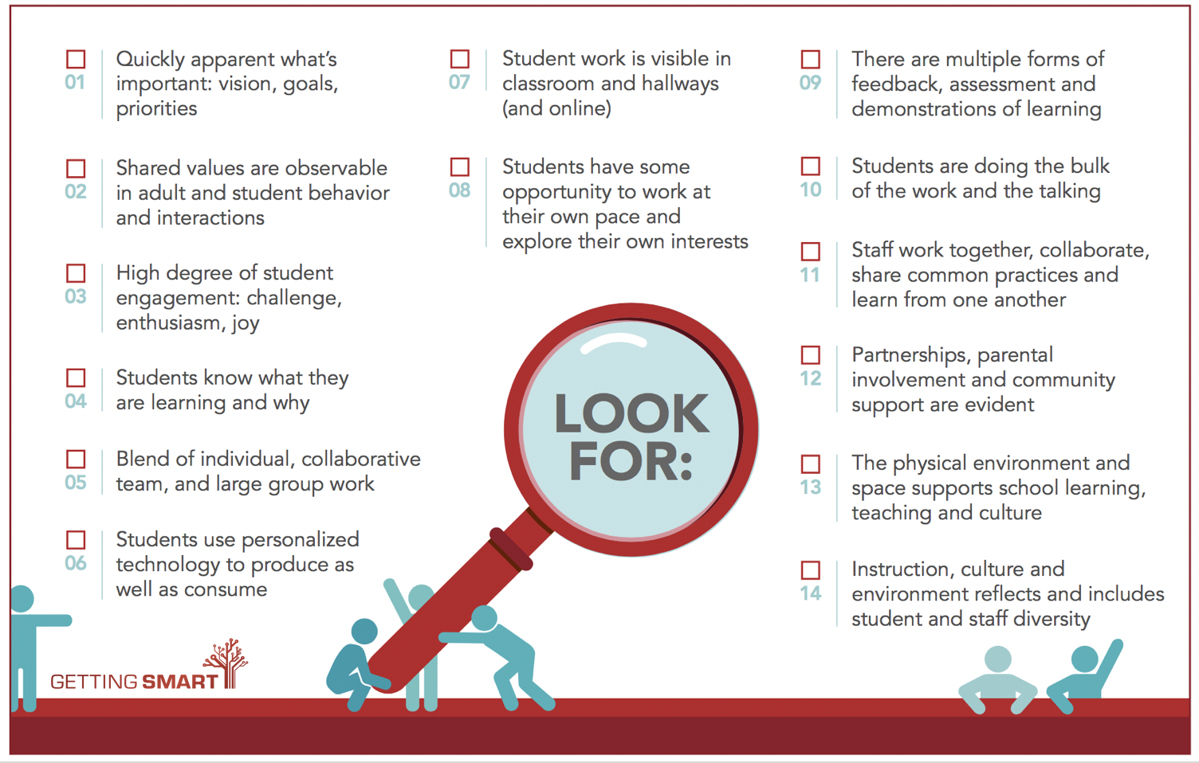

8 Things to Look for in a Student Centered Environment
(http://www.gettingsmart.com/2017/08/8-things-look-student-centered-learning-environment)

- High degree of student engagement; challenge, enthusiasm, joy .
- Students know what they are learning and why.
- Blend of individual, collaborative team, and large group work.
- Students use personalized technology to produce as well as to consume.
- Students have some opportunity to work at their own pace and explore their own interests.
- Students are doing the bulk of the work and the talking.
- There are multiple forms of assessment, feedback, and demonstration of learning.
- Instruction, culture, and environment reflect and include student and staff diversity.

Personalized Learning

Working Definition of Personalized Learning: Personalized learning is tailoring learning for each student’s strengths, needs and interests— including enabling student voice and choice in what, how, when and where they learn— to provide flexibility and supports to ensure mastery of the highest standards possible.

- Personalization is an understanding that tapping into unique interests, individual styles, and specific needs can make work and learning meaningful and authentic.
- Personalization is asking each student, “What is best for you?”
- Personalization is about relationships, knowing each individual student based on their academic and personal interests.
- Personalization is students accessing a curriculum that meets their individual needs, reflects their zone of proximal development, and gives them the opportunity to access resources to progress at their personal rate of learning.
- Personalization is engaging students with personal learner plans, where contributions from students, parents, support staff, and teachers provide a path for ubiquitous learning to address students’ individual needs, interests, and learning styles.
- Personalization is every student learning at his/her own pace using the tools that help them learn and augment their strengths.
- Personalization is meeting the learner where they are, determining where they need to be, and finding and scaffolding the right zone of proximal development to get them there.

What does personalization look like? Personalized learning…

- Is an education full of variety and choice;
- Always involves a relationship between the teacher and the student, as well as a strong sense of community within the class as a whole;
- Is a space where students have access to a wide range of subjects that meet their pathway needs and interests;
- Is, within each subject, a students’ right to access learning experiences that enable them to progress according to their level of ability;
- Is an opportunity for students to make decisions about the direction of their learning; for example, they can pick the topic they are going to research for an assignment, the book for their book chats, and how they want to write the procedures for their lab work;
- Is a dynamic learning opportunity providing students with content that addresses their personal learning needs based on their interests, parental input, and teacher observation as well as assessment data, which is the most important element;
- Is students managing their own work calendars and daily schedules to stay on track, so they are free to move through courses at their own pace and have individualized learning paths and intervention plans;
- Is students using personal learning devices, such as mobile devices to individualize their learning and improve communication within the school community;
- Is the school community including multiple layers of support;
- Is students interacting and collaborating with each other and with the content;
- Emphasizes teachers interacting with the content, with students and with other teachers;
- Necessitates social-emotional connections built between students and teachers as the foundation of their work together;
- Means various starting points within content, varied amounts of guided practice and independent practice as needed.

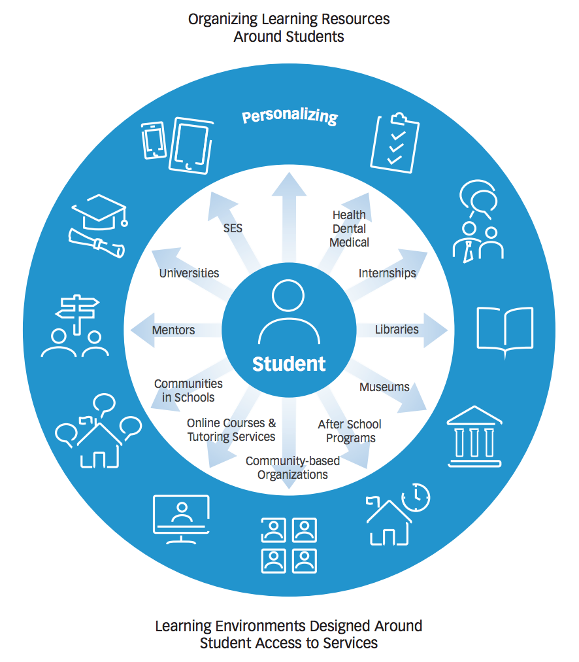

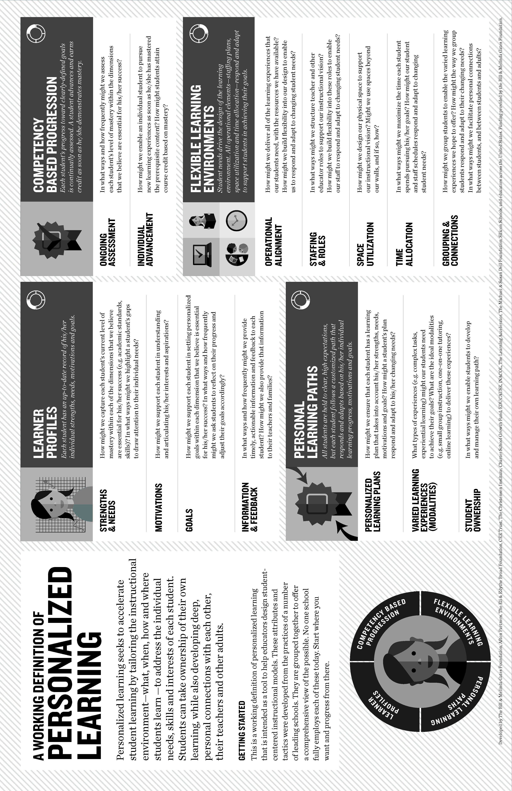
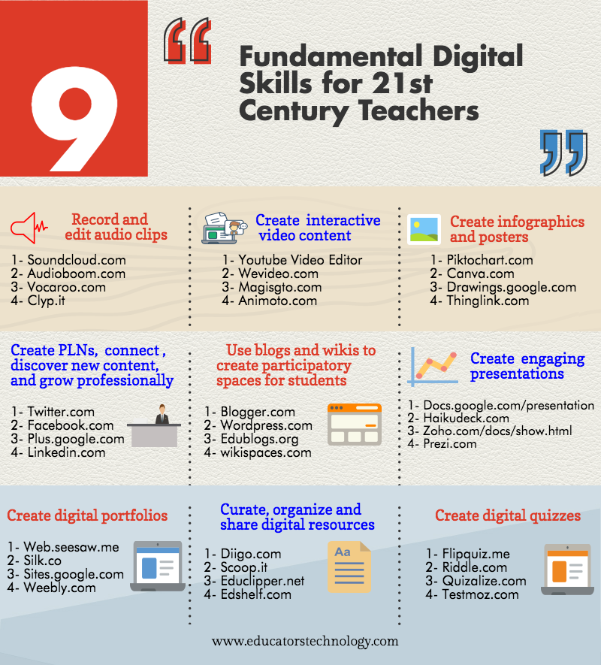

Symposium 2017: Faith Formation with a New Generation
Digital Enabled & Connected Faith Formation

Blended Learning Models

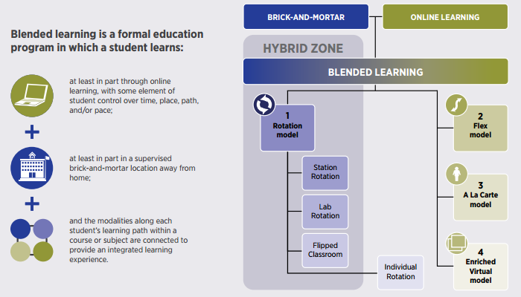

The definition of blended learning is a formal education program in which a student learns:
at least in part through online learning, with some element of student control over time, place, path, and/or pace; at least in part in a supervised brick-and-mortar location away from home; and the modalities along each student’s learning path within a course or subject are connected to provide an integrated learning experience. The majority of blended-learning programs resemble one of four models: Rotation, Flex, A La Carte, and Enriched Virtual. The Rotation model includes four sub-models: Station Rotation, Lab Rotation, Flipped Classroom, and Individual Rotation.

- Rotation model: a course or subject in which students rotate on a ﬁxed schedule or at the teacher’s discretion between learning modalities, at least one of which is online learning. Other modalities might include activities such as small-group or full-class instruction, group projects, individual tutoring, and pencil-and-paper assignments. The students learn mostly on the brick-and-mortar campus, except for any homework assignments.

- Station Rotation — a course or subject in which students experience the Rotation model within a contained classroom or group of classrooms. The Station Rotation model differs from the Individual Rotation model because students rotate through all of the stations, not only those on their custom schedules.
- Lab Rotation — a course or subject in which students rotate to a computer lab for the online-learning station.
- Flipped Classroom — a course or subject in which students participate in online learning off-site in place of traditional homework and then attend the brick-and-mortar school for face-to-face, teacher-guided practice or projects. The primary delivery of content and instruction is online, which differentiates a Flipped Classroom from students who are merely doing homework practice online at night.
- Individual Rotation — a course or subject in which each student has an individualized playlist and does not necessarily rotate to each available station or modality. An algorithm or teacher(s) sets individual student schedules.

- Flex model: a course or subject in which online learning is the backbone of student learning, even if it directs students to offline activities at times. Students move on an individually customized, ﬂuid schedule among learning modalities. The teacher of record is on-site, and students learn mostly on the brick-and-mortar campus, except for any homework assignments. The teacher of record or other adults provide face-to-face support on a flexible and adaptive as-needed basis through activities such as small-group instruction, group projects, and individual tutoring. Some implementations have substantial face-to-face support, whereas others have minimal support. For example, some Flex models may have face-to-face certified teachers who supplement the online learning on a daily basis, whereas others may provide little face-to-face enrichment. Still others may have different staffing combinations. These variations are useful modifiers to describe a particular Flex model.

- A La Carte model: a course that a student takes entirely online to accompany other experiences that the student is having at a brick-and-mortar school or learning center. The teacher of record for the A La Carte course is the online teacher. Students may take the A La Carte course either on the brick-and-mortar campus or oﬀ-site. This differs from full-time online learning because it is not a whole-school experience. Students take some courses A La Carte and others face-to-face at a brick-and-mortar campus.

- Enriched Virtual model: a course or subject in which students have required face-to-face learning sessions with their teacher of record and then are free to complete their remaining coursework remote from the face-to-face teacher. Online learning is the backbone of student learning when the students are located remotely. The same person generally serves as both the online and face-to-face teacher. Many Enriched Virtual programs began as full-time online schools and then developed blended programs to provide students with brick-and-mortar school experiences. The Enriched Virtual model differs from the Flipped Classroom because in Enriched Virtual programs, students seldom meet face-to-face with their teachers every weekday. It differs from a fully online course because face-to-face learning sessions are more than optional office hours or social events; they are required.

Source: Michael B. Horn and Heather Staker, Blended: Using Disruptive Innovation to Improve Schools (San Francisco: Jossey-Bass, 2014).
Blended Faith Formation Continuum

Fully Online  An online program with all learning done online and limited face-to-face, gathered learning settings | Mostly Online  A mostly online program with opportunities for regular interaction in face-to-face, gathered settings | Online and Gathered  Online learning focused on presenting the content of the program combined with face-to-face, gathered sessions using active learning methods to discuss, practice and apply the content. | Gathered and  Online Content  A gathered event or program that provides online content and activities to extend and expand the learning from the gathered program | Gathered with Online Content  A gathered event or program that uses online content as part of the design of the event or program

- Gathered Program with Online Content: We can design a gathered program using online content from websites, videos from YouTube or other video sites, and blogs and other social media. With an abundance of high quality digital content, this first option is the easiest way to bring the digital world into a gathered program.

- Gathered Program and Online Content: We can connect church programs or events with online content that extends and deepens the experience through learning, prayer, ritual, action, etc. Gathered events and programs such as Sunday worship, church year feasts and seasons intergenerational and family programs, classes, youth group meetings, mission trips, retreat experiences, and vacation Bible school would all benefit from extending the experience with digital content for learning, praying, celebrating, having faith conversations, acting/serving, and more.

Example: Provide a complete faith formation experience online connected to the life of the church, e.g., forty-day Lent “curriculum” that connects the Lent events at church with online content for experiencing and practicing Lent in daily and home life. For example:

Church Life Events | Daily and Home Life Activities
Ash Wednesday  Lent Sunday liturgies  Stations of the Cross  Lent prayer  Lent retreat  Lent service  Lent soup suppers | Fasting activities  Praying activities  Service/Almsgiving activities  Lectionary reflections  Lent study resources and videos  Lent devotions  Daily Bible readings

- Online and Gathered: We can “flip the classroom or program” by creating a digital platform to provide the content that people would learn in the gathered setting in an online learning space using print, audio, video, and more. And then transform the gathered program using interactive activities, discussion, project-based learning, and practice and demonstration.
Example: “Flip the classroom or program” by creating a digital platform to provide the content that people would learn in the gathered setting in an online learning space using print, audio, video, and more. And then transform the gathered program using interactive activities, discussion, project-based learning, and practice and demonstration. One example is redesigning children’s faith formation so that children and their parents are learning online at home and doing activities together, and then refocusing “class time” to engage children in creating projects and activities that demonstrate their learning. Another example is designing a high school confirmation program that provides the content that used to be taught in the weekly sessions in an online platform for individual learning—watching videos, reading short materials, and writing a reflection journals; engages the young people in small groups during the month to discuss their online learning; and then meets monthly in a large group gathered session for discussion, interactive activities, and application of the content to living as a Christian today. During the year retreats, worship, and service projects offer additional gathered sessions.

- Mostly Online: We can offer opportunities for individuals, families, and small groups to utilize the digital platform as their primary learning setting and provide opportunities for regular interaction in face-to-face, gathered settings or in a web conference format.

Example: Offer six, one-hour parent webinar programs delivered to parents at home in four-month semesters: three webinars followed by a parent gathering at church; three more webinars and concluding with a parent gathering at church. Another example is developing an online Bible study where groups can meet regularly in a physical setting or virtually through Skype or a Google+ Hangout for sharing their learning.

- Fully Online: The rise of high quality and easily accessible online religious content—courses, activities, print and e-books, audio and video programs, and content-rich websites—has made designing online faith formation feasible.

Example: Offer adults a variety of online Bible and theology courses for individual study using online courses from colleges, and seminaries, video programs on YouTube, online programs and webinars from religious publishers and organizations. Another example is providing an online prayer and spirituality center where people can access daily prayer reflections and devotions, offer prayer intentions, pray for others, learn about spiritual practices, download prayer activities for the home, and more.

Symposium 2017: Faith Formation with a New Generation
From Pathways to Faith Forming Playlists

A learning playlist is a curated group of digital and local learning experiences and resources (e.g. videos, websites, books, games, articles, etc.). A playlist weaves together these learning experiences into a sequenced pathway centered on a common theme. Playlists broaden opportunities to engage in cohesive, interest-driven connected learning experiences that combine a variety of ways to learning: peer settings, family settings, intergenerational settings, community/world settings, and online settings. Playlists create a rich network of experiences for learners.

Playlist Design

Settings
- Independent/Individualized
- Mentored
- Family / At Home
- Small Group
- Large Group
- Intergenerational /Whole Church Community
- Community and World

Multiple Intelligences
- Verbal-linguistic (word / book smart)
- Logical-mathematical (number / logic smart)
- Visual-spatial (art / picture smart),
- Bodily-kinesthetic (body / movement smart)
- Musical-rhythmic (music / sound smart)
- Naturalist (nature / environment smart)
- Interpersonal (people / group smart),
- Intrapersonal (self / introspection smart)

Methods
- Learn alone or with a group
- Read
- Write
- Engage in storytelling and create stories
- TV shows
- Feature films
- Watch or create a video
- Converse with others
- Create a media project or video
- View or create art
- View or take photographs
- Watch or engage in drama
- Listen to or create a podcast
- Listen to or create music
- Conduct a demonstration
- Experience games, simulations, video games
- Analyze or create a case study
- Develop an apprenticeship or internship
- Create an exhibit
- Experience prayer and rituals
- Take a field trip (e.g., churches, museums)
- Participate in a mission trip
- Engage in or create a service / action project
- Keep a journal
- Develop a mentor relationship
- Experience events in the congregation

Playlist Format
- Faith Maturing Characteristic
- Pathway (e.g., Exploring, Getting Started, Making Progress, Going Deeper)
- Goals for Playlist
- Plan of Faith Forming Experiences: Content, Settings, Methods, Peers/Mentors/Guides
- Demonstration of Growth

