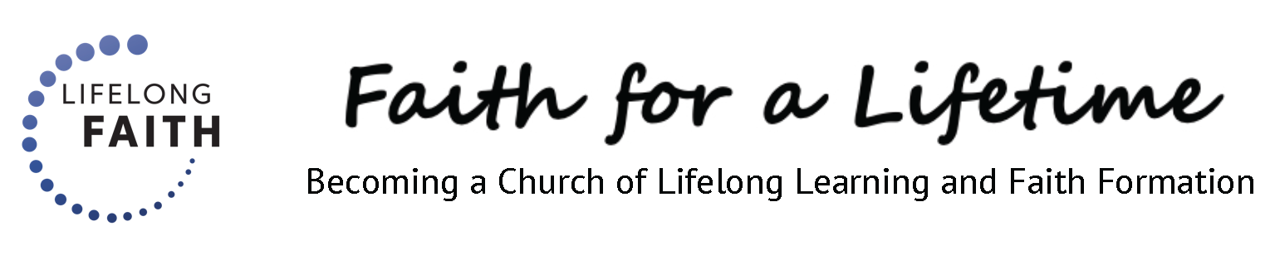

The New Context of Faith Formation

Naming What Is Changing

John Roberto

This is the fourth article in the Lifelong Faith course.

It is not an overstatement to claim that the context of faith formation has changed more dramatically in the past 10 years than the prior 50 years. We now live in a world in which everyone has felt the impact of the pandemic and its disruption to their lives and to the world.

Religious congregations have not been exempt. Many of the challenges they face today were highlighted and even accelerated by the pandemic. The decline in active engagement in church life and Sunday worship is especially worrisome to church leaders because it is so obvious today. However, the trend to lower levels of church participation and/or disaffiliation from institutional religion began in the early years of the 2000s. Now the trend is visible.

Here are five “big picture” features of the new context of faith formation which are clearly visible today and having an impact on every church’s ability to transmit faith and nurture faith growth with all ages:

- An increasingly pluralistic, secular, and diverse society which is often in tension with the Christian faith and makes it harder to nurture a faith life

- A ten-decade society with the dramatic increase of people over 60 years old

- The diversity in religious affiliation, church participation, and faith practice among all ages, but especially younger generations; and the noticeable decline of participation by families after the pandemic

- The decline in religious socialization and transmission in families and church, precipitated in part by the decrease in engagement of parents in a faith community and the rise of religiously unaffiliated parents

- The lack of support systems/communities for sustaining and living a religious identity in today’s society
- Review Chapter One in Lifelong Faith: Formation for All Ages and Generations for commentary on the changing context. (See Session 3)

Activity 1. New Context Features

In addition to the five features of the new context, what would you name as features of the new context in your faith community – features that you see having an impact on faith formation in your context?

Activity 2. Seasons of Life Profile

Develop a profile of people in each of the six seasons of life: life tasks and life situations. Use the worksheet as a guide to this activity.

Life Tasks

First, identify several of the important life tasks and needs appropriate to each season of life from developmental and spiritual/religious perspectives These tend to be consistent characteristics. For example, developmental tasks for adolescents include identity (who am I?), belonging (where do I fit?), and purpose (what difference can I make?). However the context in which young people address and resolve these tasks has changed.

- Two resource articles are included online with this article to assist you in naming life tasks and needs across the life span: “Nurturing the Faith of Young People” and “Key Life Tasks of Adulthood.”

Life Situations

Second, identify several characteristics of the life situations of people in the new context of life today. Think of people in each season of life and ask yourself: What has changed in their lives? What are their new needs, issues, and concerns? What is changing religiously and spiritually in their lives? These questions help to identify the new context for faith formation in your church community.

Analysis

Third, take one or two seasons of life and analyze the impact of the changing life situations of people upon the life tasks. What are the implications for faith formation practice? What do you need to strengthen? What do you need to stop doing? What do you need to start doing?

Seasons of Life Profile

 | Children  ( 0-10) | Teens  (11-19) | Parents of Children/Teens | Young Adults  (20s-30s) | Midlife Adults  (40s-50s) | Mature Adults (60s-70s) | Older Adults  (80s+)
Life Tasks & Needs Appropriate to the Life Stage

- Developmental
- Spiritual and Religious

Life Situations Today for Each Life Stage

- Life changes
- New needs, issues, and concerns
- Religious and spiritual changes

