Designing a Faith Formation Plan

Target Audience: ____________________________________________

Step 1. An Inventory of Current Activities
Develop a first draft of your one-year plan for your target audience by using all of the current intergenerational, family, and age group activities your congregation is currently providing, correlated to the 10 faith maturing characteristics. It's not important to "fill every box."

- Add the intergenerational (or whole church) faith forming experiences (ministries, programs, activities).
- Add the parent and family faith formation activities.
- Add the current age group programming from Week.

Faith Maturing Characteristic | Intergenerational  Faith Forming | Family  Faith Forming | Age Group  Faith Forming
1. Developing and sustaining a personal relationship and commitment to Jesus Christ
2. Living as a disciple of Jesus Christ and making the Christian faith a way of life
3. Reading and studying the Bible—its message, meaning, and application to life today
4. Learning the Christian story and foundational teachings of the Christian faith and integrating its meaning into ones life
5. Praying—together and by ourselves, and seeking spiritual growth through spiritual disciplines
6. Living with moral integrity guided by Christian ethics and values
7. Living the Christian mission in the world—serving those in need, caring for God’s creation, and acting and advocating for justice and peace.
8. Worshipping God with the community at Sunday worship, ritual celebrations, and the seasons of the church year
9. Being actively engaged in the life, ministries, and activities of the faith community
10. Practicing faith in Jesus Christ by using one’s gifts and talents within the Christian community and in the world

Step 2. New Ideas
Review your first draft: What are the strengths in our approach to promoting faith maturing using the 10 characteristics? What are the areas that need improvement? What new initiatives can we create to build upon strengths and address areas in need of improvement? Add these new ideas to your first draft.

Step 3. Digital Methods and Media
How can you use digitally enabled strategies to improve, expand, or create new faith formation programming. Identify specific ways you can integrate digital methods and media into your first draft plan.

- Extend programming. Which current programs can you extend using online programming? Identify the kinds of content you would provide online to extend each program.
- Flip the program using online content. Which programs are good candidates for flipping the content, i.e., is there high-quality digital content (audio, video, visual, print) available in an online format? Identify the programs you could flip. What will be available online? What will the gathered session look like when the content is online?
- Online programming. What types of programs can you create online? How can you deliver programming online (webinar, streaming presentation)? How can you develop an online resource center as a portal to curated content?
- Multiformat programming. Which programs are good candidates for multiformat programming? What would a design look like for one multiformat program?
- Prepare and follow-up programming. Which programs can you use a digital strategy to prepare people online for an event or program and then follow up with online content and activities? What would a design for one program look like?

Step 4. A "Menu" of Faith Formation for a Year.
Create a plan for the year, based on your current and new programming, that integrates the three faith forming environments. The goal is to provide a holistic year of faith formation that integrates all three environments. Use the work you have done on the "Designing" worksheet. Be sure to use digital strategies where appropriate.

- Intergenerational (whole church community)
- Family and Parents at Home and at Church
- Age Group (young children or grade school children or middle school young people)

Create your plan so that it is written in a style and language appropriate to your target audience, e.g., parents of young children, parents and grade school children, parents and young adolescents. Here's an example of a one-year plan from a Jewish Synagogue that integrates intergenerational, family, and age group faith forming experiences.

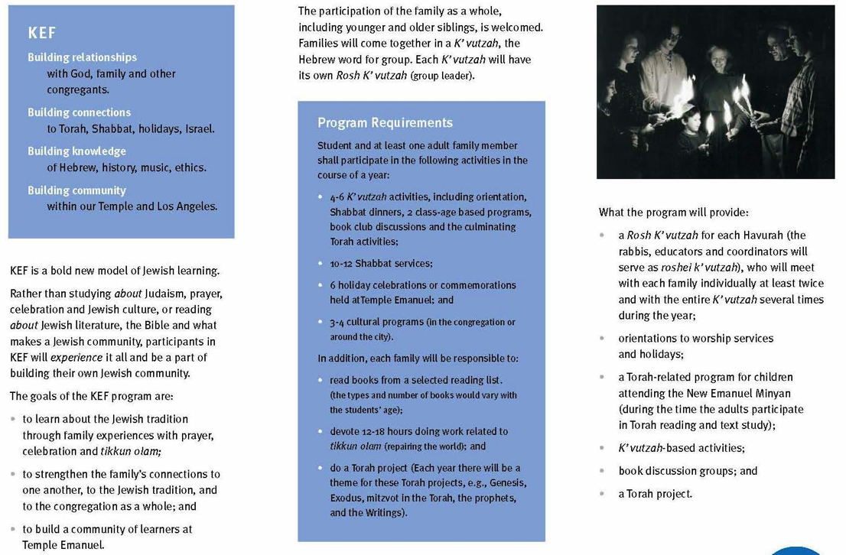​

Step 5. Promotion and Presentation.
Develop a plan for introducing the annual plan to your target audience with a live or video presentation and a booklet (print or digital), calendar, webpage, etc.

