Families at the Center of Faith Formation

John Roberto, LifelongFaith Associates (jroberto@lifelongfaith.com)

Changing the Questions
- What does a vibrant and vital family faith look like in a 21st century world?
- How do we meaningfully engage/connect with today’s families?
- How do we empower/equip/resource families to transmit faith at home - to practice a vital and vibrant faith?
- How do we reach families who are not involved in a faith community or feel religion is not important?

What is Changing in Families
- Diversity of Family Forms: no dominant family form in U.S.
- Generational Parenting: Gen X—Protecting Parenting; Millennia—Responsive Parenting
- Diversity of Ethnicities: ethnic identities, histories, and religious traditions and practices
- Diversity of Spiritual-Religious Identities: Engaged-------Occasionals--------Spirituals-------Unaffiliated

What Makes a Difference in Faith Growth

- Parents’ personal faith and practice
- Parent-child relationship: close and warm
- Parents’ modeling and teaching a religious faith
- Parents’ involvement in church life
- Grandparents’ religious influence & relationship
- Religious tradition a child is born into
- Parents of the same faith
- Family conversations about faith
- Embedded family religious practices: praying, reading the Bible, serving, celebrating holidays and rituals

Families at the Center of Faith Formation: Changing the Narrative
The Family-at-the Center Approach recognizes that parents and the family are the most powerful influence for virtually every child and youth outcome—personal, academic, social, and spiritual-religious; and that parents are the most important influence on the social and religious lives of children, youth, and emerging adults. Given the central role of families in shaping the lives of children and youth, the value of engaging, supporting, and educating families should be self-evident to all of us.

- See the home as the essential and foundational environment for faith nurture, faith practice, and the healthy development of young people.
- Reinforce the family’s central role in promoting healthy development and faith growth in children and youth, and enhancing the faith-forming capacity of parents and grandparents.
- Express care with the families in our congregations and communities, including listening to them, showing interest in their lives, and investing in them.
- Provide support and advocacy when families really need it.
- Share power with families, treating them as true partners by giving them voice in things that matter to them and collaborating with them to solve problems and reach goals.
- Build faith formation around the lives of the today’s families and parents, rather than having the congregation prescribe the programs and activities that families will participate in.
- Address the diversity of family life today by moving away from “one size fits all” programs and strategies toward a variety of programs and strategies tailored to the unique life tasks and situations, concerns and interest, and religious-spiritual journeys of parents and families.
- Offer regular gatherings of all families for learning, worship, service, relationship-building, and more throughout the year.
- Engage families together with the whole community for learning, worship, service, relationship-building, and more throughout the year.
- Find ways to reach families at home with support, resources, and activities to develop family life and grow in faith.
- Strengthen families by helping them develop the practices and skills for healthy family life.
- Equip parents with the knowledge and skills for effective parenting and forming faith in young people.

Families at the Center of Faith Formation: Strategies

- Discovering God in Everyday Life
- Forming Faith at Home through the Life Cycle
- Forming Faith through Milestones
- Celebrating Seasonal Events through the Year
- Encountering God in the Bible through the Year
- Connecting Families Intergenerationally
- Developing a Strong Family Life
- Empowering Parents and Grandparents

Forming Family Faith: Processes & Content
- Caring Relationships. Growing in faith and discipleship through caring relationships across generations and in a life-giving spiritual community of faith, hope, and love—in the congregation and family.
- Celebrating the Liturgical Seasons. Growing in faith and discipleship by experiencing the feasts and seasons of the church year as they tell the story of faith through the year in an organic and natural sequence of faith learning.
- Celebrating Rituals and Milestones. Growing in faith and discipleship by celebrating rituals, sacraments, and milestones that provide a way to experience God’s love through significant moments in one’s life journey and faith journey .
- Learning the Christian Tradition and Applying It to Life. Growing in faith and discipleship by learning the content of the tradition, reflecting upon that content, integrating it into one’s faith life, applying it to life today, and living its meaning in the world.
- Praying, Devotions, and Spiritual Formation. Growing in faith and discipleship through personal and communal prayer, and being formed by the spiritual disciplines.
- Reading the Bible. Growing in faith and discipleship by encountering God in the Bible, and by studying and interpreting the Bible—its message, its meaning, and its application to life today.
- Serving and Justice. Growing in faith and discipleship by living the Christian mission in the world—engaging in service to those in need, care for God’s creation, and action and advocacy for justice.
- Worshipping God. Growing in faith and discipleship by worshipping God with the community of faith—praising God; giving thanks for God’s creative and redemptive work in the world; bringing our human joys and dilemmas to God; experiencing God’s living presence through Scripture, preaching, and Eucharist; and being sent forth on mission.

Families at the Center of Faith Formation: Programming
- A variety of relationships, content, experiences, and resources
- New methods: immersive, multimedia, multi-sensory, highly visual, participatory, experiential
- New formats: episodic engagements and experiences, micro-learning, on demand, mobile, 24x7
- New digital media and digital platforms; connect with parents/families through social media; redesign programming with digital connections and extensions; address new needs through online experiences
- Multiple environments: self-directed, mentored, at home, in small groups, in large groups, church-wide, in the community, and in the world.
- Multiple versions: design a program once and offer it in multiple formats and environments, e.g., a gathered program that is recorded and can be used for individual study or small group study

Digitally Enabled and Digitally Connected Faith Formation

Online Face-to-Face
Fully Online  An online program with all learning done online and limited face-to-face, gathered learning settings | Mostly Online  A mostly online program with opportunities for regular interaction in face-to-face, gathered settings | Online and Gathered  Online learning focused on presenting the content of the program combined with face-to-face, gathered sessions using active learning methods to discuss, practice and apply the content. | Gathered and  Online Content  A gathered event or program that provides online content and activities to extend and expand the learning from the gathered program | Gathered with Online Content  A gathered event or program that uses online content as part of the design of the event or program

Websites

- www.LifelongFaith.com
- www.ReimagineFaithFormation.com
- www.CuratingFaithFormation.com
- www.FamiliesattheCenter.com
- www.SeasonsofAdultFaith.com
- http://vibrantfaithathome.org

Books
Families at the Center or Faith Formation. John Roberto, editor. (LifelongFaith, 2016).
Reimagining Faith Formation for the 21st Century. John Roberto (LifelongFaith, 2015).

Catholic Profile

CARA & Holy Cross Family Ministries

(http://www.hcfm.org/en/AboutUs/FamilyResearch.aspx)

Importance of Catholic Faith
About half of parents (49 percent) say that their Catholic faith is either the most important part of their life or among the most important parts of their life
Parents All adults
The most important part of your life 15% 14%
Among the most important parts of your life 34% 27%
Important, but so are many other areas of your life 39% 40%
Not too important in your life 9% 13%
Not important in your life at all 3% 6%

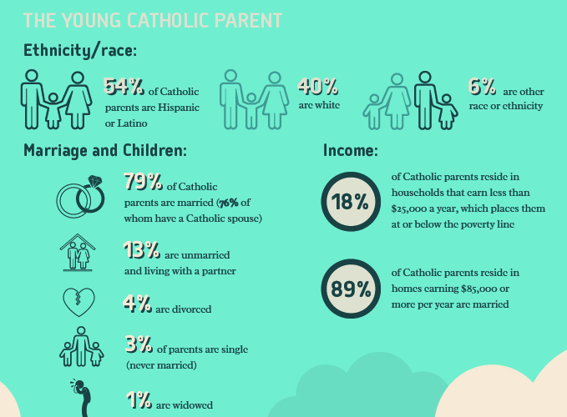

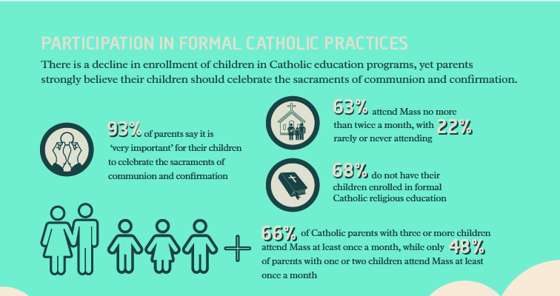

What’s Your Congregation’s Approach to Families?

Identify your congregation’s approach with families using the following questions. (See Chapters 1 and 3 in Families at the Center of Faith Formation for background.) For each question, identify your congregation’s current practice with parents and/or families using the rating scale:
1 = not at all 3 = often 5 = a lot.

- We express care with the families in our congregations and communities, including listening to them, showing interest in their lives, and investing in them. | 1 | 2 | 3 | 4 | 5
- We challenge growth in families by expecting them to live up to their potential and helping them learn from their mistakes. | 1 | 2 | 3 | 4 | 5
- We provide support and advocacy when families really need it. | 1 | 2 | 3 | 4 | 5
- We share power with families, treating them as true partners by giving them voice in things that matter to them and collaborating with them to solve problems and reach goals. | 1 | 2 | 3 | 4 | 5
- We encourage families to expand possibilities by connecting them with other people, ideas, and opportunities to help them grow. | 1 | 2 | 3 | 4 | 5
- We offer regular gatherings of all our families for learning, worship, service, relationship-building, and more throughout the year. | 1 | 2 | 3 | 4 | 5
- We engage families together with the whole community for learning, worship, service, relationship-building, and more throughout the year. | 1 | 2 | 3 | 4 | 5
- We find ways to reach families at home with support, resources, and activities to develop family life and grow in faith. | 1 | 2 | 3 | 4 | 5
- We strengthen families by helping them develop the practices and skills for healthy family life. | 1 | 2 | 3 | 4 | 5
- We equip parents with the knowledge and skills for effective parenting and forming faith in young people. | 1 | 2 | 3 | 4 | 5
- We engage parents as leaders and contributors in the congregation and in the community. | 1 | 2 | 3 | 4 | 5
- We design ministries, projects, and activities that complement and reinforce the role of families in faith formation. | 1 | 2 | 3 | 4 | 5
- We recognize the family as the epicenter of faith formation across the generations. | 1 | 2 | 3 | 4 | 5
- We celebrate the evidence of vibrant faith at work in the everyday lives of families and their young people. | 1 | 2 | 3 | 4 | 5

Family Faith Practices

1. Please select up to 10 practices from the list below that you consider the most important family faith practices for helping children and teens grow in faith (place a check mark in the left column). In the right column, please check the practices that your family actually does – today or in the past.

Most Important In Our Family
- Praying as a family (meal time, bedtime)
- Praying as a family during times of struggle or crisis
- Encouraging teens to pray alone or with peers
- Reading the Bible as a family
- Encouraging teens to read the Bible alone or with their peers
- Celebrating rituals and holidays at home
- Serving people in need as a family
- Serving people in need as individuals (parents, teens)
- Eating together as a family
- Having family conversations
- Talking about faith as a family
- Watching videos, movies, or TV shows with religious content or themes
- Encouraging teens to talk about their doubts and questions about faith
- Talking about faith and your religious tradition with your children and teens
- Asking your teenager's perspectives on faith, religion, social issues, etc.
- Providing moral instruction
- Demonstrating a warm and affirming parenting approach
- Taking time to growing in your own faith as a parent
- Engaging in positive communication with children and teens
- Encouraging children and teens to pursue their talents and interests
- Spending one-on-one time with children and teens
- Participating in Sunday Worship as a family
- Inviting friends of your teen to join in family practices (Sunday worship, service, prayer)
- Celebrating the church year seasons at church (Advent/Christmas, Lent/Easter)
- Celebrating rituals and sacraments at church as a family
- Participating in church life activities as a family
- Encouraging and supporting your teen to participate in church activities with peers

2. Are there other faith practices that your family engages in (or engaged in) that were not listed above.
3. What are two or three of the biggest challenges your family faces (or faced) in trying to live these faith practices? Please share these challenges.

