Kenora Catholic School System

Educators Session – Monday, October 24

Schools that Nurture Faith & Develop the Spiritual Life

John Roberto

Today’s Context

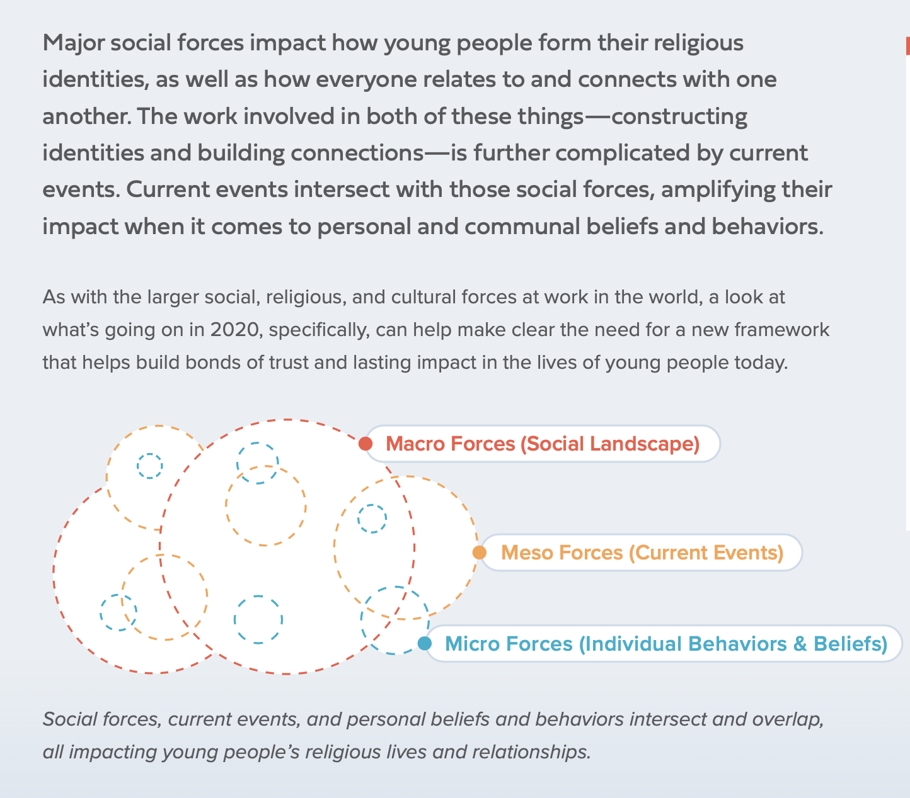

Consider these contemporary emerging challenges . . . .

- The wellbeing (and mental health) of children, teens, and their parents
- Record levels of loneliness among young people
- The search for meaning, purpose, and belonging among the younger generations
- Increased connectivity, decreased connection
- The loss of trust and confidence in society’s institutions
- Gender identity, gender expression, and sexual identity have changed substantially
- The diversity of religious belief and practice; decline in religious affiliation

Through Relationships

(Search Institute)

Developmental relationships are close connections through which young people discover who they are, cultivate abilities to shape their own lives, and learn how to engage with and contribute to the world around them.

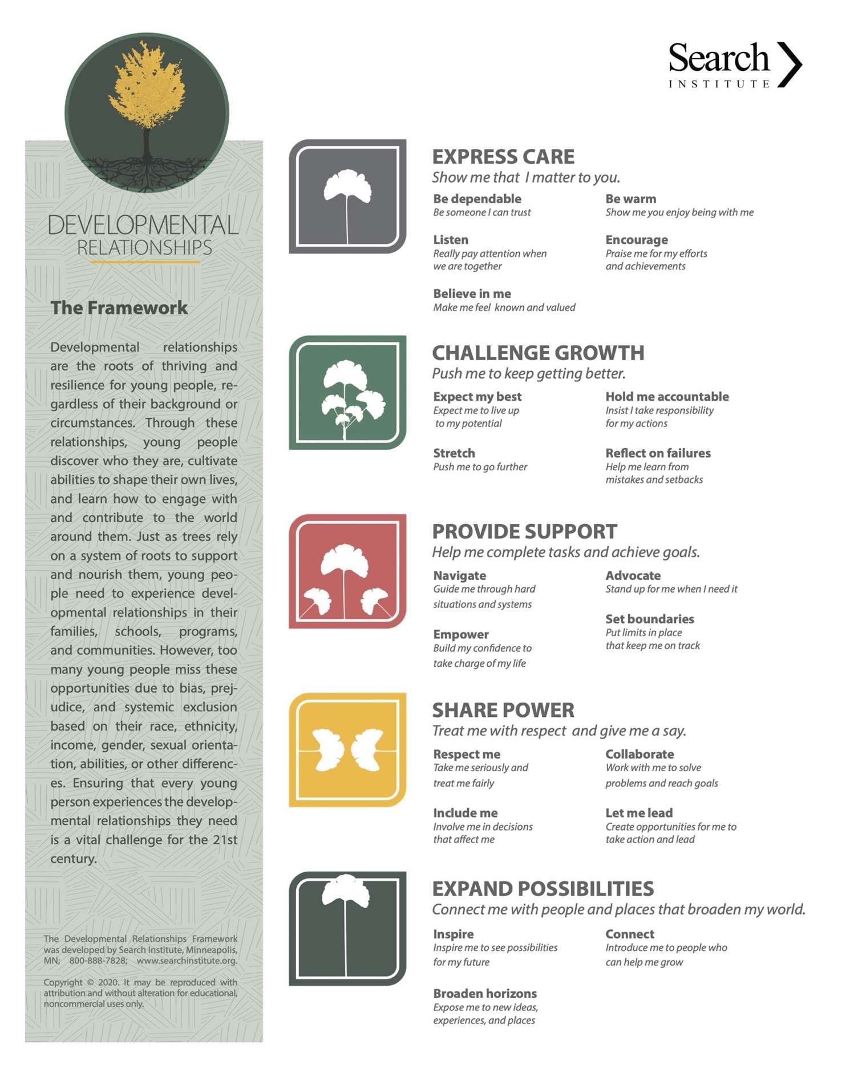

Ideas for Building Developmental Relationships

Express Care

- Pay attention. Focus on youth when they are talking about things that matter to them.
- Follow up with young people when you learn about what they are going through something, rather than waiting for them to bring it up again.
- Make time for lightness. Share in some humor, fun, and laughter amid the practical tasks.
- Strive to understand and show sensitivity to students’ feelings.
- Use varied teaching strategies to make learning enjoyable, and to help students connect with you and each other.

Challenge Growth

- Highlight future goals. Talk with young people about the things they look forward to or dream about.
- Expand their thinking by asking hard questions, providing alternate explanations, and encouraging openness to different opinions. This helps them expand their own thinking.
- Emphasize mistakes are a necessary part of learning. Praise them for hard work, whether they succeed or fail.
- Emphasize mastery and self-improvement more so than doing better than other students.
- Challenge students to reach high expectations. Hold them accountability.

Provide Support

- Offer information and practical help to solve a practical problem.
- Show young people how to ask for help when they need it.
- Shift levels of support. Give more support when young people are struggling, and less when they are making progress. Step back as their skills and confidence build.
- Provide specific and descriptive feedback for students to use toward their improvement.
- Teach strategies for performing and learning under pressure.

Share Power

- Let young people make decisions about activities you do together and what you talk about. Don’t jump in too fast when they don’t make quick decisions or think of things to talk about.
- When you can, offer choices (“So, what could you do differently to tackle this problem?”), rather than always giving instructions.
- Learn from young people—and show it. Young people have a lot to teach adults. Let them know when you’ve learned something from them that you’re excited about.
- Give students classroom choices within rules and safety limits.
- Ask students for input on assignments, class content, and how they can show proficiency.

Expand Possibilities

- When young people seem curious about an activity, topic, or issue, ask questions such as “what strikes you about this?”
- Introduce young people to a wide range of people, places, ideas, cultures, and vocations. Start with ones they’re curious about.
- Broaden the web of relationships. Connect young people to people who share their interests or can expand their world.
- Demonstrate how what students are learning relates to their interests and to success outside of school and in the future.
- Connect students with educators, other students, and community members who can explore with them areas of personal interest and strength.

Reflection Worksheet: Developmental Relationships

How true is each statement for you. Think of how the statement reflects your relationships with students?
(Rating on a 1-5 scale: 1= not true from me , 3 = somewhat true for me, 5= very true for me)

- I express care for students by being someone who they can trust, who listens to them, believes in them, and encourages them.
- I challenge students to grow by expecting them to live up to their potential, holding them accountable, and helping them learn from failures.
- I provide support to help students complete tasks and achieve goals by building up their self-confidence, standing up for them when need, and guiding them through hard situations.
- I treat students with respect, involve them in decisions that affect them, work with them to solve problems and reach goals, and create opportunities for them to take action and lead.
- I work to expand students' possibilities by inspiring them to see possibilities in their future, expose them to new ideas and experiences, and connect them to people who can help them grow.

- What are some of the ways you practice the five developmental relationships with students.

- How can you improve your practice of the five developmental relationships with students.

Through Belonging

(Springtide Research)

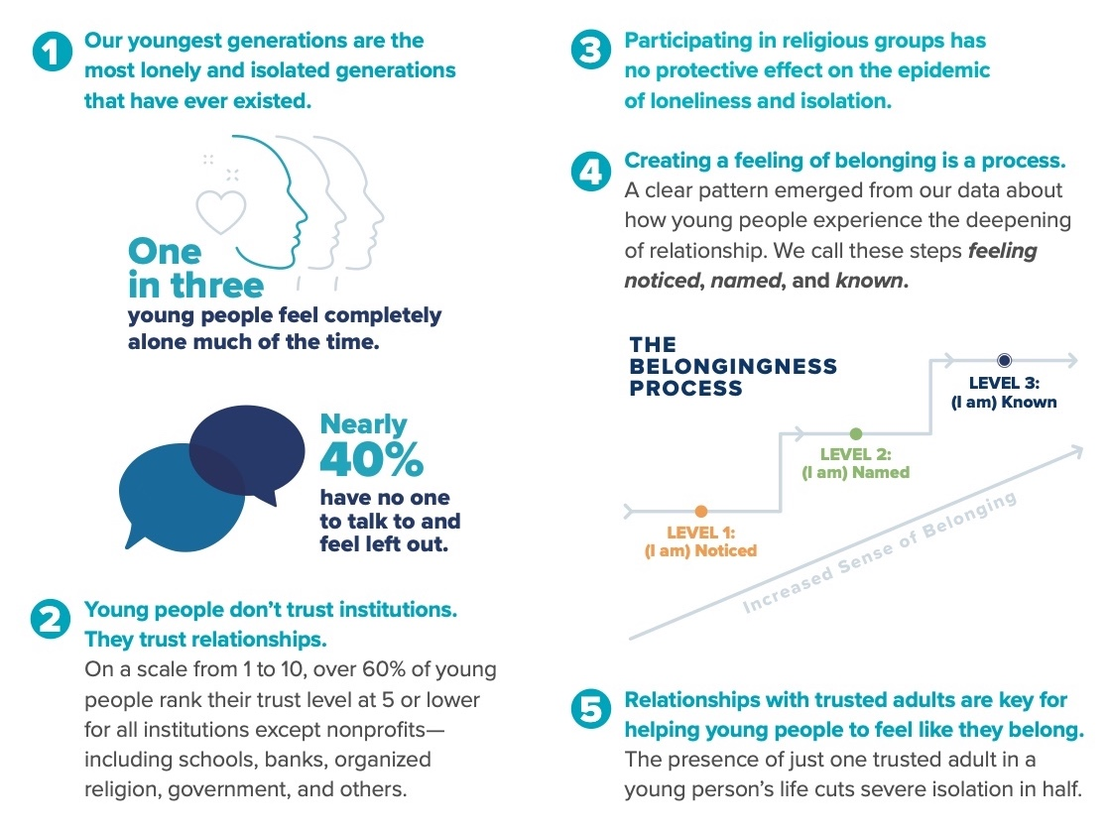

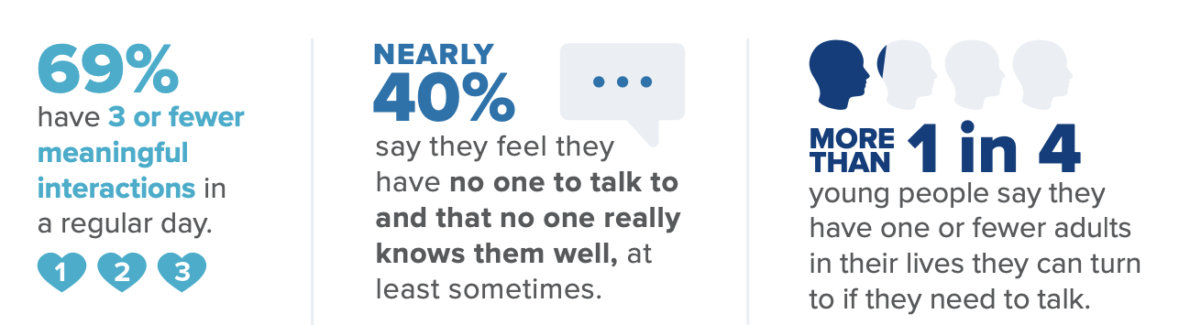

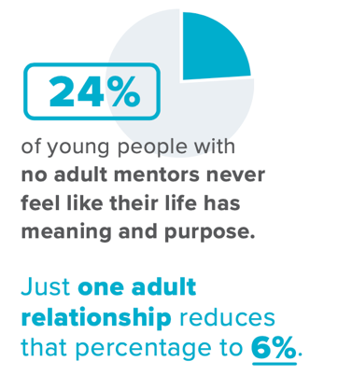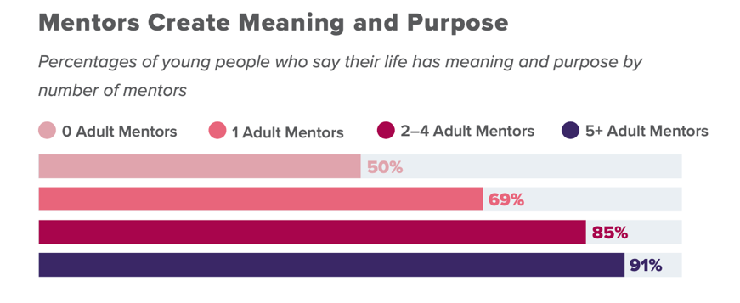

Practicing Relational Authority

Young people engage and thrive when they encounter trusted adults who care for, listen to, and guide them. Educators and religious leaders are needed to meet young people amid the messiness of the present moment.

Relational Authority is a framework for connecting with others in light of changing social, cultural, and religious dynamics at work in the world. It is a response to the reality that in a society increasingly connected by impersonal bonds, we often need deep, familiar connection before feeling receptive to the influence or guidance
of others.

Listening, transparency, integrity, care, and expertise are the five dimensions of Relational Authority. Young people trust adults who practice all five dimensions of relational authority.

Listening is being curious about, engaged in, and remembering what another person said.  Transparency is sharing experiences, seeking commonalities, and being open with information that impacts others.  Integrity is following up, following through, being accountable, and being authentic.  Care is a commitment to the patient and careful work of supporting young people as they navigate questions of identity, community, and meaning.  Expertise is specialized wisdom and skill that, when combined with listening, transparency, integrity, and care, is the foundation for meaningful relationships. | 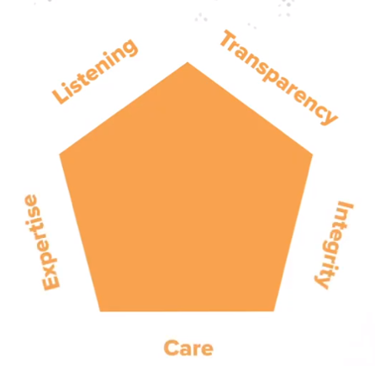

Relational Authority is rooted in relationships and earned, not through credentials or titles, but through practices of sympathetic expertise shaped and offered through shared experience.

Relational Authority is a framework based on the understanding that young people often need to feel they are cared for before they can be receptive to the influence or authority of others in their lives. Young people want to feel they belong: They want to feel Noticed, Named, and Known. Relational authority is a framework for building this kind of bond through concreate practices.

Better bonds, earned trust, and lasting influence in your relationships with young people are built on the five dimensions of Relational Authority: listening, transparency, integrity, care, and expertise. Intentionally practicing Relational Authority is a commitment to listening, caring for, engaging, and guiding young people as they navigate some of life’s biggest questions and concerns. The result, for those who are committed and intentional in the practice, is invaluable: lasting impact in the lives of young people, built on shared experience and sympathetic expertise.

Reflection Worksheet: Relational Authority

- Listening is being curious about, engaged in, and remembering what another person said.
- Transparency is sharing experiences, seeking commonalities, and being open with information that impacts others.
- Integrity is following up, following through, being accountable, and being authentic.
- Care is a commitment to the patient and careful work of supporting young people as they navigate questions of identity, community, and meaning.
- Expertise is specialized wisdom and skill that, when combined with listening, transparency, integrity, and care, is the foundation for meaningful relationships.

- What are some of the ways you practice the five dimensions of relational authority with students.

- How can you can improve your practice of the five dimensions of relational authority with students.

Through a Community of Faith & Practice

Schools that educate and form students in the Catholic faith and spiritual life create a community that engages students (and adults) in the following Catholic Christian practices as integral to the school’s identity and mission.

Community Life
- Honoring and respecting the dignity of each person, who is created in the image and likeness of God
- Believing in the living presence of God in each person, in the community, and in the world
- Being a community of hospitality and welcome for all people
- Celebrating the cultural diversity in the community and their unique faith, heritage, and traditions

Spiritual & Religious Life
- Fostering a personal relationship with Jesus Christ
- Finding a life of meaning and purpose in living the Christian faith as a way of life
- Experiencing, exploring, and reading the Bible and how its message applies to life today
- Exploring the Catholic Christian story and faith tradition, and discovering its meaning for life today
- Worshipping God through liturgies and Masses
- Celebrating the church year seasons
- Learning to pray, and praying—alone and with others
- Growing spiritually through prayer practices, spiritual disciplines, and retreat experiences
- Learning to live with moral integrity guided by Christian values
- Serving those in need, caring for God’s creation, and acting and advocating for justice and peace
- Discovering personal God-given gifts and learning how to use them to benefit the community and world

For children: The emphasis is on experiencing faith and belonging to a faith community. Schools provide an immersion into the Catholic faith through faith forming practices embodied in the life of the school community.
For adolescents: Building on experiencing and belonging in childhood, the emphasis moves to the young person building or constructing a spiritual/religious life by exploring, discerning, and integrating beliefs and practices into one’s life.

- What are some of the ways your school is living these 15 practices for nurturing faith and the spiritual life?

- How can your school improve the way it is living these 15 practices for nurturing faith and the spiritual life?

The Challenge of Spiritual and Religious Diversity

- Declining numbers of people (children, teens, adults) participating in religious communities
- Increasing age (and deaths) of the Christians most engaged in a religious community
- Rising numbers of disaffiliation among younger generations (40s and younger)
- Rising number of children growing up in second generation religiously unaffiliated home, i.e., their parents disaffiliated and not transmitting a religious faith and practice at home

A Continuum of Belief and Practice

Inactive Nonbelievers  Do not believe in God | Inactive Believers  Believe in God, attend religious services less than once a month, and only slightly spiritual | Spiritual but not Religious  Very or moderately spiritual persons but attend religious services less than once a month | Involved Believer  Believe in God and attend religious services at least once per month | Active Believer  Believe in God, attend religious services weekly, involved in a church community

One of the consequences of the disaffiliation and involvement trend is the decline in passing on faith from generation to generation. Who is socializing the next generation into the Christian faith? Who is enriching the faith life of parents and grandparents and equipping them to transmit the Christian faith to the young? How can we develop the foundations for a life of faith in the new generation and their parents?

- What are some of the ways your school is responding to the spiritual and religious diversity of students and their families?

- How can your school improve its response to the spiritual and religious diversity of students and their families?

Through Spiritual Role Models

The role of all adults in the school is critical in creating an environment that nurtures faith and the spiritual life. The following attributes of adults in the school have been found to be the most influential in supporting the personal and spiritual lives of students.

Personal
- I see my work at the school as a vocation.
- I recall that I am in the holy presence of God each day.
- My vocation as an educator is important to me.
- My faith inspires my work as an educator/adult member of the school community.
- My spiritual growth is important to me.
- I see myself as a spiritual role model for students entrusted to my care.
- I view Jesus Christ as a model for me as an adult member of the school community.
- My vocation is inspired and sustained by my relationship with God.
- I read the Bible regularly.
- I pray regularly.
- I am personally engaged in service to those in need and actions for justice in my community and the world.
- I am involved in a local faith community (church, synagogue, mosque).

Community
- I recognize God's presence in the lives of students entrusted to my care.
- The spiritual and religious growth of students is important to me.
- I actively support and encourage students in their spiritual and religious growth.
- It is important for me to contribute to the spiritual and religious growth of the whole school community.
- I participate with students in activities that promote their spiritual and religious growth: praying with them, reading the Bible with them, participating in retreats, service projects, and liturgies.
- I participate in spiritual/religious formation opportunities for educators at the school and in the district.

- Which of these 18 attributes best describes you?

- Which of these 18 attributes would you like to develop or enhance?

